



Mark-up of Swiss Confederation Laws in AkomaNtoso XML (LegalDocML)

An Open Governance Initiative

Release: Draft
Date: 29 September 2025
Author: Giona Fumasoli (BK)

Document History
Revision date | Author | Version | Summary of Changes
29.09.2025 | GF | 0.1 | Draft
18.12.2025 | GF | 0.2 | First review after meeting with KAV
02.02.2026 | GF | 0.3 | Addition of the missing points
06.03.2026 | GF | 0.4 | Insertion of feedback, addition of new chapters, numbers formatting

Contents
1. INTRODUCTION 5
2. HIERARCHY OF SWISS LAW 6
3. SPECIFIC SWISS LEGAL DOCUMENTS IN XML 7
4. MODELLING OF SWISS LEGAL DOCUMENTS 8
4.1. Categorization of the Document Type 8
4.2. Structural Elements of the Document type 9
4.2.1. Sub-structural Elements 10
4.3. Metadata 11
4.4. Akoma Ntoso structure of a legal document 16
4.4.1. Document structure 16
4.4.1.1. Modelling 16
4.4.1.2. Example 17
4.4.2. Identification part: <preface> 18
4.4.2.1. Examples 18
4.4.3. Justificatory text: <preamble> 20
4.4.3.1. Examples 20
4.4.4. The main content: <body> 22
4.4.4.1. Examples 24
4.4.5. Closing formula: <conclusion> 26
4.4.5.1. Example 26
4.4.6. Annexes: <attachments> or <components> 27
4.4.6.1. Example 27
5. AKN TAGGING FOR STRUCTURAL BLOCKS 28
5.1. Metadata 28
5.2. Shared elements 31
5.3. Element borrowed from HTML 32
5.4. Identification – IRI (Normative) vs. ELI 33
5.4.1. Introduction to compliant IRI syntaxes 33
5.4.2. European Legislation Identifier (ELI) 33
5.4.3. Fedlex Naming Convention 33
5.5. Microstructure 34
5.5.1. Micro-structure elements 34
5.5.2. Special hierarchical constructs 37
5.5.2.1. Proviso (final disposition or final provision) 37
5.6. Transitional (disposition or provision) 37
5.7. Article content 38
5.7.1. Paragraphs 38
5.7.2. Lists 39
5.7.3. Footnotes 40
6. MODIFICATIONS 45
7. TABLES 46
8. IMAGES 46
9. FORMULAS 46
10. ANNEXES 47
11. List of Annexes 48
Annex I 49

INTRODUCTION
Akoma Ntoso for Switzerland (AKN4CH) also called Fedlex XML is not simply the customization of an XML standard, it is a methodology and the occasion to re-engineer the internal work processes and to innovate the document workflow in the light of the digitalization.
The AKN standard is very flexible to any possible scenario, this makes it fundamental in a scenario like the project of the OPC (KAV) to decide how to adopt AKN including all the requirements of the actors involved in the law-making process to attend the goal of a paperless society.
The objective is to improve interoperability between different institutions, to support interexchange between existing IT legacy systems, to reduce redundant and reiterative tasks, to enhance quality of the drafting and publication activities, to release documents in open government data form.
In order to produce a large benefit in all the institutions of the Swiss Confederation it is necessary an official AKN4CH guidelines that provide clear, reliable and common specifications to all the stakeholders. This document is designed for legal practitioners, technical experts, and stakeholders in legal informatics who are engaged in the creation, maintenance, and use of legal documentation in digital formats.
The Information Model described in this document (based on the Jolux Ontology of the Government of Luxembourg) is the cornerstone for the digital publication of Switzerland's legal documents:
- the Federal Gazette (or Bundesblatt also referred to as BBl),
- the Official Compilation (or Amtliche Sammlung also referred to as AS), and
- the Classified Compilation (or Systematische Rechtssammlung also referred to as SR)
These documents are seamlessly integrated into Fedlex, Switzerland's premier platform for the dissemination of federal law, ensuring accessibility and transparency in legal proceedings.
The model described in this guide is based on the globally recognized Akoma Ntoso standard, as delineated by the LegalDocML Technical Committee at Oasis Open. Documents that align with the guidelines described here, are assumed to adhere strictly to the XML schema (akomantoso30.xsd), publicly available from the Appendix B of the Akoma Ntoso specification.
Given the extensive documentation, available on the Akoma Ntoso specification, this guide will focus on the applications and constraints that are distinctive to the Swiss legal system. As such this document aims to provide a tailored framework that aligns with the national legal traditions while maintaining international standards.

HIERARCHY OF SWISS LAW
Swiss law is known for its neutrality, pragmatism, and emphasis on political entities autonomy:
- Federal Constitution: The supreme law of Switzerland, establishing the foundation for the country's legal and political system.
- Federal Laws: Legislation enacted by the Swiss Federal Parliament.
- Cantonal Laws: Laws established by the individual cantons, which retain sovereign rights not assigned to the Confederation.
- Communal Laws: Laws at the municipal level, often dealing with local matters.
- International Law: Treaties and conventions ratified by Switzerland are also integrated into the Swiss legal framework.
The document contains examples in all the official languages as all the language versions will be marked up in the same way as, legally, they are considered equivalents.
Akoma Ntoso, an OASIS XML standard, is a framework for representing various Swiss (and international) legal and legislative documents that provides a consistent way to tag these documents for machine readability, improving digital processes and information management:
- Standardized Structure: Akoma Ntoso provides a common, flexible schema for different legal document types.
- Flexibility: While it uses common structures, it is flexible enough to accommodate the unique characteristics of national legal systems and practices, including language and specific document types.
- Digitalization: It supports the digitalization of legislative processes by enabling machine-readable formats, helping to manage and access them more efficiently.
- Metadata and Referencing: The standard allows for detailed metadata and unambiguous references between documents, which is crucial for long-term storage, analysis, and creating interconnected legal information services.

SPECIFIC SWISS LEGAL DOCUMENTS IN XML
- Enacted Legislation: Laws that have been passed and are in force, often published in the Swiss Official Compilation (AS) or Federal Gazette (BBl).
- Proposed Legislation (bills): Legislation under consideration by parliament.
- Amendments: Formal changes to existing laws.
The Swiss Laws are open structure documents, sometimes articulated in hierarchical structures in which the text is subdivided into higher and lower subdivisions, generally including a preamble and operative paragraphs.
The approach in this guide is twofold:
  - Model Restrictions: the information model will be articulated through a series of business rules that refine the “Akoma Ntoso” model to suit the needs of the Swiss Federal legislation.
  - Illustrative Examples: actual cases from published documents will illuminate the model's application, demonstrating that theoretical knowledge is grounded in practical use.
The “model restrictions” in this document can be considered a non-formal expression of the business rules outlined in a more formal specification. This formal specification can be found in the form of a Schematron schema, a set of rules identified as “AKN-fedlex.sch”.
This guide can be read in parallel with its formal counterpart. Where applicable, a model restriction will reference the identifier of the matching restriction in the schematron schema available in Annex I. The identifier will be shown in square brackets as follows: [example-ID].
A typical validation scenario for an XML document that would be fully aligned with the guidelines in this reference, would be a combined validation using the generic XML schema for Akoma Ntoso and the Fedlex specific Schematron schema.
This reference should be regarded as a living resource, always reflective of the latest standards and practices. Hence, feedback is most welcome. Periodic updates to the content can be expected, in order to keep pace with evolving needs and legislative changes.
Note: in the remainder of this guide, on using the word “XML”, the “machine readable XML expression of the Fedlex Information model, based on Akoma Ntoso” is implied.

MODELLING OF SWISS LEGAL DOCUMENTS

Categorization of the Document Type
Akoma Ntoso  Document Types | Category /  Legal Document | Definition
bill/act | Akoma Ntoso type :  hierarchicalStructure  Legal Document :  bill/act/ordinance/decree/subsidiary legislation/executive orders/ normative standard/ administrative regulation/etc. | These are deliberative documents produced by parliamentary activities or from other empowered bodies.  They are usually drawn up according to a hierarchical structure in which the text is divided into sections or chapters subdivided into clauses or articles, sub-paragraphs, etc.
doc | Akoma Ntoso type :  openStructure  Legal Document:  any other type of document/Executive SummaryMemorandum/etc annexes/table/judicial documents | These are texts that are legally valid but do not have any particular structure. These include any parliamentary procedure document that has no particular textual structure and is not a collection of other documents. An example could be also the Report of the Amendments of a Bill, the Memorandum of a Bill, Order of Business, Legal Notice, judicial documents, etc.
officialGazette | Akoma Ntoso type :  collectionStructure | Used to represent an issue of an official publication body such as Official Compilation, Journal, Bulletin or Federal Register.
amendment | Akoma Ntoso type : amendmentStructure  Legal Document:  Amendment document | Used to describe specific amendment documents. It is a special document or a component of an amendment list, presented by the member(s) of parliament to a committee or assembly for discussion.
amendmentList | Akoma Ntoso type:  collectionStructure | Used to represent a special document that includes all the amendments, collected and submitted to the official deliberative body for the discussion.
documentCollection | Akoma Ntoso type :  collectionStructure  Legal Document :  collection of documents | Used to represent documents which are collections of other independent documents. A typical example is the electronic folder related to a bill. This folder is composed of several independent documents and by different expressions over time such as versions of the same bill.

Structural Elements of the Document type
Document type | Akoma Ntoso  main element | Description
bill/act | <body> | The body is used for bills and acts and presents an explicit hierarchy of parts that can be identified with a meaningful name (such as section, chapter, etc.) and possibly provided with numbers and various types of headings.  Akoma Ntoso provides a large number of names for these parts (title, book, tome, part, chapter, section, paragraph, article, clause, division, level, list, subtitle, subpart, subchapter, subsection, subparagraph, subclause, sublist, point, indent, alinea). Some legislative traditions may use names which may not match the part names specified above – for such cases a generic container called an hcontainer (i.e. hierarchical container) is provided which can be identified with a name and supports the same hierarchical structures provided by the named parts.
Doc (document)  debateReport, statement | <mainBody> | The mainBody element of an open structure is a generic collector of all preceding structural elements in any order and number. This kind of open structure is meant for collecting and marking up those document types whose structure is too varied, or too different from the norm, or not well standardized, or too full of exceptions to be worth describing explicitly.
Collections | <collectionBody> | The collectionBody is used for including multiple documents that maintain their autonomy, but can be managed as a unique container. It is thus possible to compose an issue of the Official Compilation as a combination collection of several acts. The same for the Amendment List document composed of a set of separate amendment documents. This structure permits two different approaches:  - to include directly in the collectionBody element the other documents (bill, doc, debate, act, etc.);  - to include in the collectionBody element references to the documents using the element <documentRef>. The documentRef includes the attribute href that specifies the URI/IRI of the document. The cited document can be described in the same file inside of the element <component> or to link an external file using the URI/IRI.  It is possible to associate with each sub document a num and a heading.  A <documentRef> is a work-level or expression-level reference to a document that has independent existence, namely that it has a work-level or expression-level identifier, and that it is hosted within a containing document.
Amendment | <amendmentBody> | This element includes the body of the amendment that is composed of several important parts: <amendmentHeading>, <amendmentContent>, <amendmentReference>, and <amendmentJustification>.

Sub-structural Elements of the Document type
Sub-structural element | Akoma Ntoso  main element | Description
Information on the document | <metadata> | Information on the document that qualifies and classifies the text as a whole or each fragment. An example is the keywords for assigning the topic to the document.
Introductory text | <preface> / <header> | The essential information related to the citing of the document, like the title of the document, the proponent authority, the identification numbers, the date of approval. It can also contain the long title and a table of contents.
Justificatory text | <preamble> that can  include <formula>  <recitals>  and <citations> | The introductory part of a document stating its purpose, aims, and justification, introduction, motivations, purposes, legal basis of a document, in formula, recitals and citations. Formula describes the enacting sentences that, in many legal traditions, are regular and fixed linguistic expressions. Recitals block includes motivations and justifications of the legal document. Citation blocks include references to other legal documents that are fundamental to the current text: legal basis, preparatory acts as well as the legislative procedures.
Main content | <body>: for bill/act  <debateBody>: for debate record  <judgmentBody>: for judgments  <mainBody>: for open structure and for the debate report  <amendmentBody>: for the amendment  <collectionBody>: for the collection documents  <portionBody>: for the portion of document |  | The main part of the document, the part that is prescriptive or states a declaration (enacting terms). The text is characterized by a structural complexity that can vary depending on the document’s typology and purpose.
Conclusions | <conclusions> | Part in which we may find closing formulas date and signature.
Authorial notes | <authorialNote> | Part dedicated to including the authorial notes added by the author of the document.
Attachments | <attachments> | Documents can also include attachments with the function of completing and integrating information of the main text. Attachments can be an annex (informative or technical data which, does not appear in the body).  Attachments or other types of Components can also be another act or international agreement that is approved by this act. Those documents are not annexed but attached to the act that approves them. Those documents are not annexed but attached to the act that approves them.
Components | <components> | Document can also include components that are independent works, expressions, or manifestations.  Each component can have a< num> and/or a <heading> before the document.

Metadata
The Dublin Core is probably the most widespread and famous schema for metadata structures as applied to electronic documents. Yet, its generality limits the flexibility of metadata for the scopes and extent of applications internal to an organization. Far more interesting appear to be initiatives such as the one sponsored by the International Federation of Library Associations (IFLA), called Functional Requirements for Bibliographic Records (FRBR), which tries to capture several different natures in documents, such as the persistent characteristics of different versions of the same document, as expressed in the Work/Expression/Manifestation/Item specification of Akoma Ntoso.

Below you can see the metadata of a concrete example of the law on street traffic (Strassenverkergesetz, also referred to with the abbreviation SVG)
- WORK: the abstract concept of the legal resource (e.g., SVG of 2025)

 | Bibliographical context | Legal Context
WORK | “Work” is a distinct intellectual or artistic creation at the conceptual level.  Qualifying characteristics: identity e.g. Hamlet = work  Regardless of versions, variants, revisions, data formats and location. Even if a “Work” is translated in different languages, it is still the same document, the same “work”. | “Work” refers to the original “content” of the legal document.  For examples, the abstract concept of the legal resource;
 | Example taken from the Swiss legislation
<FRBRWork>
<FRBRthis value="https://fedlex.data.admin.ch/eli/cc/1959/679_705_685/20250401/main-text"/>
<FRBRuri value="https://fedlex.data.admin.ch/eli/cc/1959/679_705_685/20250401"/>
<FRBRdate date="2025-04-01" name="jolux:dateApplicability"/>
<FRBRdate date="1959-10-01" name="jolux:dateEntryInForce"/>
<FRBRdate date="1958-12-19" name="jolux:dateDocument"/>
<FRBRauthor href="#ch.bk" as="#publisher"/>
<FRBRauthor href="#ch.bk" as="#rightsHolder"/>
<FRBRcountry value="CH"/>
<FRBRnumber value="741.01"/>
<FRBRname xml:lang="de" value="Strassenverkehrsgesetz vom 19. Dezember 1958 (SVG)" shortForm="SVG"/>
<FRBRname xml:lang="fr" value="Loi fédérale du 19 décembre 1958 sur la circulation routière (LCR)" shortForm="LCR"/>
<FRBRname xml:lang="rm" value="Lescha davart il traffic sin via dals 19 da december 1958 (LTV)" shortForm="LTV"/>
<FRBRname xml:lang="it" value="Legge federale del 19 dicembre 1958 sulla circolazione stradale (LCStr)" shortForm="LCStr"/>
<FRBRauthoritative value="true"/>
</FRBRWork>

- EXPRESSION: any version of the WORK (whose content is specified and different from others for any reason: language, versions, etc.)
 | Bibliographical context | Legal Context
EXPRESSION | “Expression” is the specific intellectual or artistic form that a work takes each time it is ‘realized.  Qualifying characteristics: content  e.g. Hamlet original version book = expression or Hamlet original version video = expression  All different editions of the same version of the document, all are unified by the fact that they express the same actual content. | “Expression” refers to “form” of the legal document.  For examples, any version of the “work” whose content is specified and different from others for any reason: language, versions, etc.;
 | Example taken from the Swiss legislation
<FRBRExpression>
<FRBRthis value="https://fedlex.data.admin.ch/eli/cc/1959/679_705_685/20250401/fr/main-text"/>
<FRBRuri value="https://fedlex.data.admin.ch/eli/cc/1959/679_705_685/20250401/fr"/>
<FRBRdate date="2025-04-01" name="jolux:dateApplicability"/>
<FRBRdate date="1959-10-01" name="jolux:dateEntryInForce"/>
<FRBRdate date="1958-12-19" name="jolux:dateDocument"/>
<FRBRauthor href="#ch.bk" as="#publisher"/>
<FRBRauthor href="#ch.bk" as="#rightsHolder"/>
<FRBRlanguage language="fr"/>
</FRBRExpression>
- MANIFESTATION: any electronic or physical format of the EXPRESSION: word, xml, pdf, etc.
 | Bibliographical context | Legal Context
manifestation | “Manifestation” is the physical embodiment of an “expression” of a “work”. It is a specific form that the document assumes once it takes a concrete representation.  Qualifying characteristics: data format  e.g. Hamlet original version book – or Hamlet original version video DVD  For physical documents, it could be a specific edition as published in a specific choice of paper, binding, etc. For electronic documents, it is the choice of a specific data format, process method, and so on. | “Manifestation” refers to the realization of the publishing work either on paper or in any electronic format.  For examples, any electronic or physical format of the “expression” MS Word, Open Office, XML, TIFF, PDF, etc.
 | Example taken from the Swiss legislation
<FRBRManifestation>
<FRBRthis value="https://fedlex.data.admin.ch/eli/cc/1959/679_705_685/20250401/fr/xml/main-text"/>
<FRBRuri value="https://fedlex.data.admin.ch/eli/cc/1959/679_705_685/20250401/fr/xml"/>
<FRBRdate date="2025-04-01" name="jolux:dateApplicability"/>
<FRBRdate date="1959-10-01" name="jolux:dateEntryInForce"/>
<FRBRdate date="1958-12-19" name="jolux:dateDocument"/>
<FRBRauthor href="#ch.bk" as="#publisher"/>
<FRBRauthor href="#ch.bk" as="#rightsHolder"/>
<FRBRformat value="xml" fedlex:generator="2025-q2-rel-1.7.2"/>
</FRBRManifestation>
- ITEM: physical copy of any manifestation in the form of a file stored somewhere in some computer on the net or disconnected.
FRBR concepts are used differently when taking about documents in a variety of situations.
 | Bibliographical context | Legal Context
Item | “Item” is one physical copy of a document in a concrete form of a “manifestation” of an “expression” of a “work”.  Qualifying characteristics: location  e.g. Hamlet original version book – hardback version of the Shakespeare Library, London  It could be an individual volume in a bookshelf, or a specific file in a specific directory of a specific computer.  Qualifying Characteristic: positions or address | “Item” refers to a univocally identified exemplar of a certain manifestation.  For examples, the physical copy of any manifestation in the form of a file stored somewhere in some computer on the net or disconnected;  e.g. the file called act32005.pdf on my computer containing a PDF representation of act 3, 2005
In each case it is important to use the URI/IRI for the correct FRBR level of document. We describe here a few particularly frequent situations:
1. Legislative references will most probably refer to WORKs: acts referring to other acts do so regardless of the actual version, and references must be to something independent of all possible expressions, e.g., to the work.
2. The list of attachments and schedules belong to a specific EXPRESSION, so references to ExpressionComponents is specific of the expression level.
3. Within XML files the URI/IRI of the Manifestation must be used to refer to all components, including the main document, all attachments and all schedules.
4. Multimedia fragments within an XML manifestation (e.g., a drawing, a schema, a map, etc.) do not exist as independent ExpressionComponents, as they are a part of some ExpressionComponents. In fact, they are only ManifestationComponents, and as such are referred to in object and img elements with the appropriate ManifestationComponents URI/IRI. Even if the same multimedia content appears in different parts of the content of a Manifestation, each instance of that content must correspond to a different ManifestationComponent, and must be considered independently of the other.
5. It is an Item-level decision, once verified that the content is identical, to provide space-saving policies by storing only one copy of the multimedia content. This Item-level decision has no impact on references and names, which are still individually different from each other.
6. Non-document concepts are referred to within the metadata and content of Akoma Ntoso documents. References are always performed in two steps: the first step ties the reference point in the document to an item in the Reference section using internal IDs; the second step ties the item in the reference section to the actual concept through the URI/IRI of the concept.
The following table illustrates the difference between the URIs of the same situations:
Work | <FRBRuri value="https://fedlex.data.admin.ch/eli/cc/1959/679_705_685/20250401"/>
Expression | <FRBRuri value="https://fedlex.data.admin.ch/eli/cc/1959/679_705_685/20250401/fr"/>
Manifestation | <FRBRuri value="https://fedlex.data.admin.ch/eli/cc/1959/679_705_685/20250401/fr/xml"/>
The difference between the URIs above is the following:
- the URI of the Work is the link to the initial version of a specific document
- the URI of the Expression ends with the specification of the language version of that specific document
- the URI of the Manifestation ends with the specification of the document format of that specific version of the document in that specific language version.

This table illustrates the difference of the metadata elements contained in the three situations with the following colour codes:
- In green font are the elements that are common to the three specifications. These elements contain the specification of the URIs of the document, the specifications of the dates of the document, the publisher and the rights holder that in our case is the Federal Chancellery.
- In blue font are the elements that belong only to the Work These elements contain the indication of the languages of the base versions in which that document is available and the indication of the title in each language. Moreover, it also contains information on the legal authoritativeness of the document.
- In purple are the elements that belong only to the Expression. This element indicates the language of that specific version.
- In orange are the elements that belong only to the Manifestation. This element indicates the format of that specific version.

Work | Expression | Manifestation
<FRBRWork>  <FRBRthis>  <FRBRuri>  <FRBRdate name="jolux:dateApplicability">  <FRBRdate name="jolux:dateEntryInForce">  <FRBRdate name="jolux:dateDocument">  <FRBRauthor as="#publisher">  <FRBRauthor as="#rightsHolder">  <FRBRcountry>  <FRBRnumber>  <FRBRname xml:lang="de">  <FRBRname xml:lang="fr">  <FRBRname xml:lang="rm" >  <FRBRname xml:lang="it" >  <FRBRauthoritative>  </FRBRWork> | <FRBRExpression>  <FRBRthis>  <FRBRuri>  <FRBRdate name="jolux:dateApplicability">  <FRBRdate name="jolux:dateEntryInForce">  <FRBRdate name="jolux:dateDocument">  <FRBRauthor as="#publisher">  <FRBRauthor as="#rightsHolder">  <FRBRlanguage language>  </FRBRExpression> | <FRBRManifestation>  <FRBRthis>  <FRBRuri>  <FRBRdate name="jolux:dateApplicability">  <FRBRdate name="jolux:dateEntryInForce">  <FRBRdate name="jolux:dateDocument">  <FRBRauthor as="#publisher"/>  <FRBRauthor as="#rightsHolder"/>  <FRBRformat value="xml">  </FRBRManifestation>

Akoma Ntoso structure of a legal document
A typical Swiss Law is made up of the following structural blocks:

Document structure
The structure of normative documents may contain the following elements:
Identification part (Preface)  Title, proponent authority, identification, etc. | always present
Justificatory text (Preamble)  Purpose, motivations, justification or legal basis. | not always present.
Main content  Main text usually articulated in hierarchical structures. | always present
Closing formula  Closing formulas, date etc. | not always present.
Attachments  Informative or technical documents. | not always present.

Modelling
The table below illustrates how an act element functions as a container that holds and organizes the document's content, ensuring the structural integrity and legal validity.
document type | <akomaNtoso>  <act contains="originalVersion" name="{AKN4CH:subclass}">
metadata | <meta>  <identification source="#{manifestationAuthor}">  </identification>  </meta>
identification part | <preface>  (...)  </preface>
justificatory text | <preamble>  (...)  </preamble>
main content | <body>  (...)  </body>
closing formula | <conclusions>  (...)  </conclusions>
attachments | <attachments>  (...)  </attachments>
Closing Tag | </act>  </akomaNtoso>

Examples
Below are some practical examples of the Akoma Ntoso mark-up of the main blocks of a normative document.
document type  source | <akomaNtoso>  <act contains="originalVersion" name="{AKN4CH:subclass}">
identification part | <preface>  ………  </preface> | 
preamble | <preamble>  ………  </preamble> | 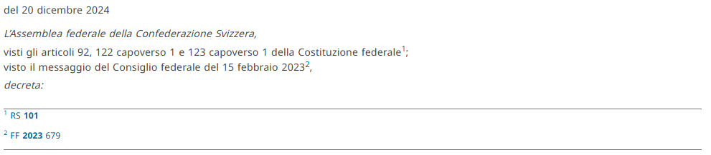
main content | <body>  ………  </body> | 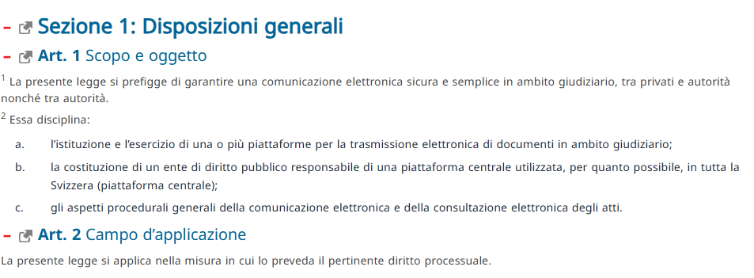
closing formula | <conclusions>  …..  </conclusions> | 
annexes | <attachments>  …..  </attachments> | 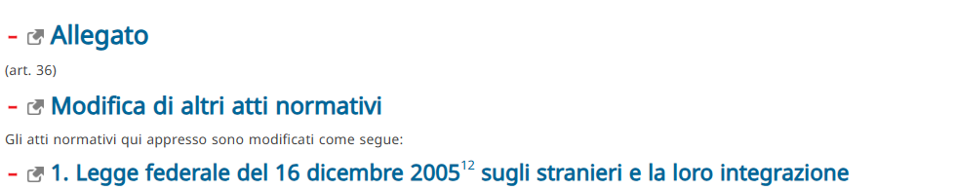

Identification part: <preface>
The identification part <preface> includes any matter found from the very beginning of a document up to where the <preamble> begins. It may contain information related to the title of the document, proponent authority, identification numbers, date of approval, etc. It may include long titles, tables of contents, and the like.
Normative documents may start with some or all of the information below, not necessarily in the same order:
- document type, for example
- title, for example “”
- document authority, for example
- acronym , for example
- identifier, for example
- date of adoption, for example
Key aspects of the Akoma Ntoso <preface> element:
- Purpose: To contain descriptive and identifying metadata about the document.
- Content: Includes details like the document's title, number, authors, and date.
- Structure: at the beginning of a document, before the <preamble> and main <body>.
- Distinction from Preamble: While both are introductory, the <preface> is for identification, whereas the <preamble> provides justification and context.
- Inline Elements: inline elements like <docTitle> and <docNumber> are often used to mark up specific pieces of identifying information.
In the AKN4CH schema, the <preface> element is used for introductory, identifying information that appears at the beginning of a document, such as the document's name, title, number, authors, and date. It may also include content understood as a preface.
The preface holds some essential information, with certain details being mandatory for the document's validity.

Examples
Notably, the document number (identified as docNumber) and the document title (docTitle) must be present and correctly located within the preface for the document to be considered valid. The image below illustrates how the docNumber and docTitle are incorporated into the preface, ensuring that this information is easily identifiable and accessible.
source | 
modelling | 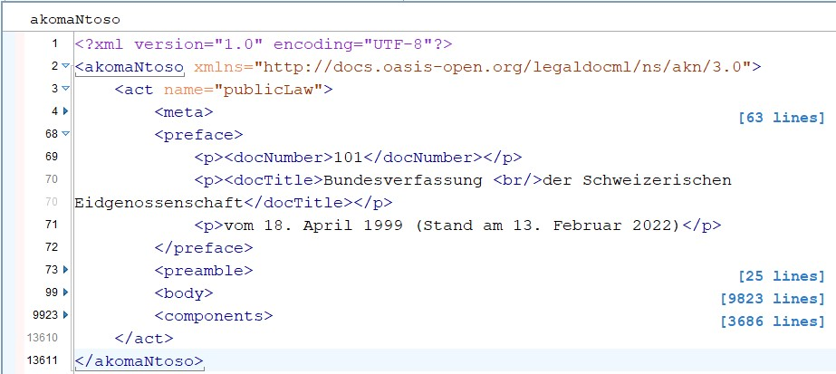

However, the document number is not always present, as shown in the example below:
source | 
modelling | 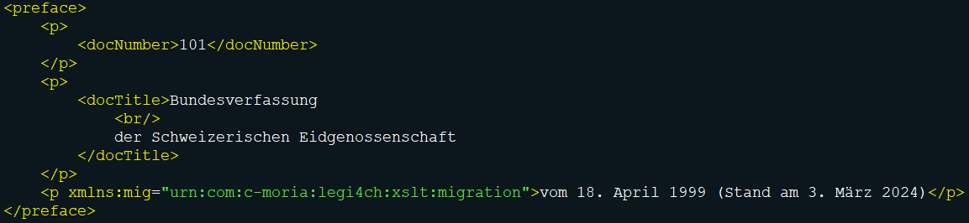

The <preface> is a mandatory structure element for the file to be a valid Akoma Ntoso xml.

Justificatory text: <preamble>
The justificatory text includes any matter found after the <preface> up to where the <body> begins. It may contain one or more paragraphs stating purpose, aims, and justification of a normative document. They may refer to the legal basis, other normative documents, statements, etc.
This part may consist of one or more different paragraphs, usually not numbered, which state the considerations on the legal basis and rationale of a document. At times it might be structured as a single long sentence formatted into multiple paragraphs for readability, in which each paragraph begins with a verb.
The preambular part usually begins with an "enacting formula", followed by unnumbered paragraphs.
The preamble typically begins with a present, past or perfect participle or participial phrase in italics, and ends with a comma. Preamble paragraphs may be subdivided as follows:
- First-degree sub-paragraphs: e.g. identified by lower-case letters between parentheses.
- Second-degree sub-paragraphs: e.g. identified by lower-case roman numerals between parentheses.
Some or all the informational parts below, but not necessarily in the same order, may be found:
- Recitals: motivations and justifications of the legal document.
- Citations: references to other legal documents.
- Enacting Formula: enacting sentences.
- Paragraph(s).
Key aspects of the Akoma Ntoso <preamble> element:
- Purpose: To explain the reasons and intent behind the document, such as a constitution or statute.
- Content: May include informational parts like enacting sentences (<formula>), preambular paragraphs (<p>), and containers (<container>) to group them.
- Structure: Can be one or more paragraphs, sometimes starting with a verb.
- Elements: Uses specific Akoma Ntoso elements to structure the text, such as:
  - <preamble>: The main element to contain the preambular text.
  - <formula>: To mark enacting or promulgation sentences.
  - <p> or <container>: For the actual preambular paragraphs.
  - <crossHeading>: To explicitly identify preambular paragraphs when referring to the concept of a preamble.

Examples
In the context of Akoma Ntoso, the <preamble> element that marks the introductory part of a legal or official document, stating its purpose, aim, and justification. It may consist of one or more paragraphs, often starting with a formula identifying the authorities that are promulgating the document, and can include preambular paragraphs and concluding formulas.
source | 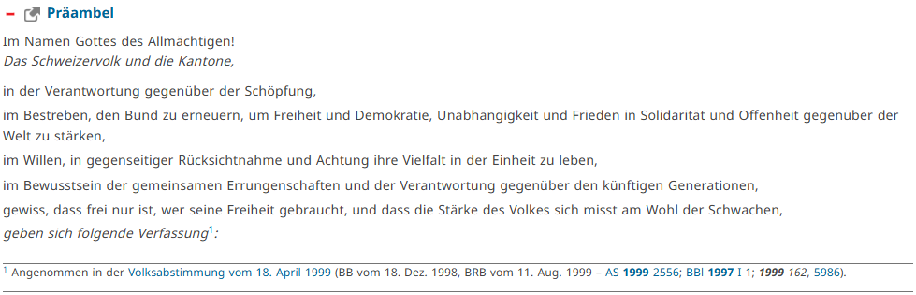
modelling | 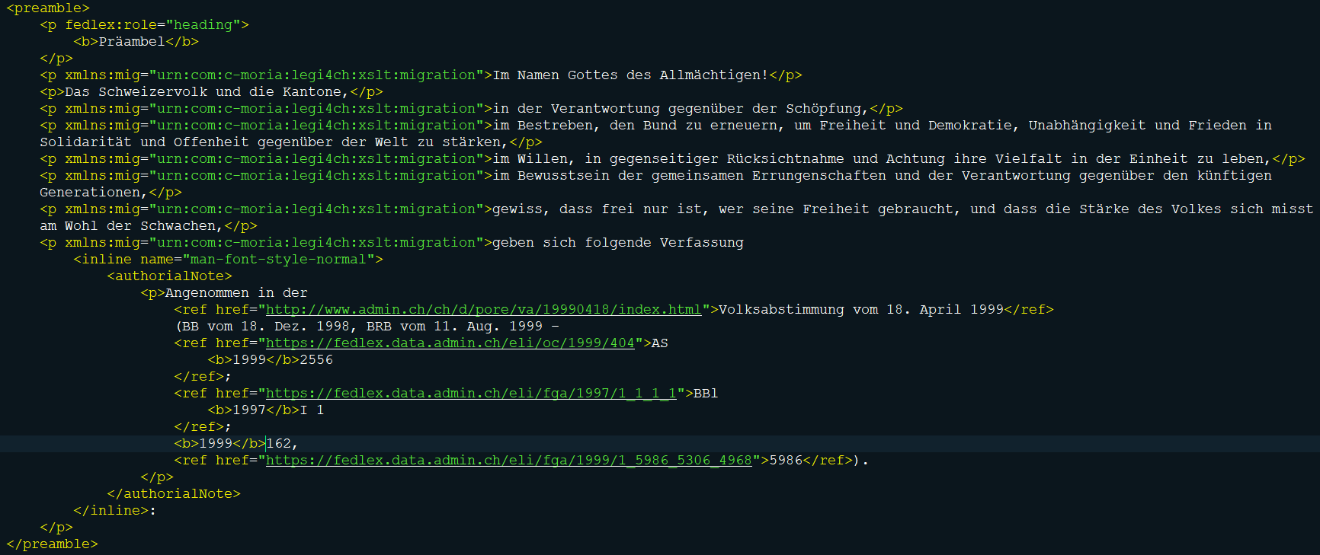

However, the document number is not always present, as shown in the example below:
source | 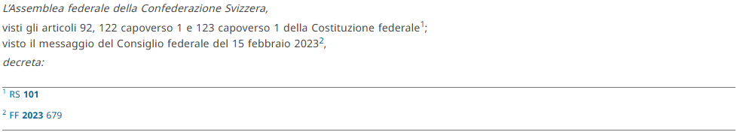
modelling | 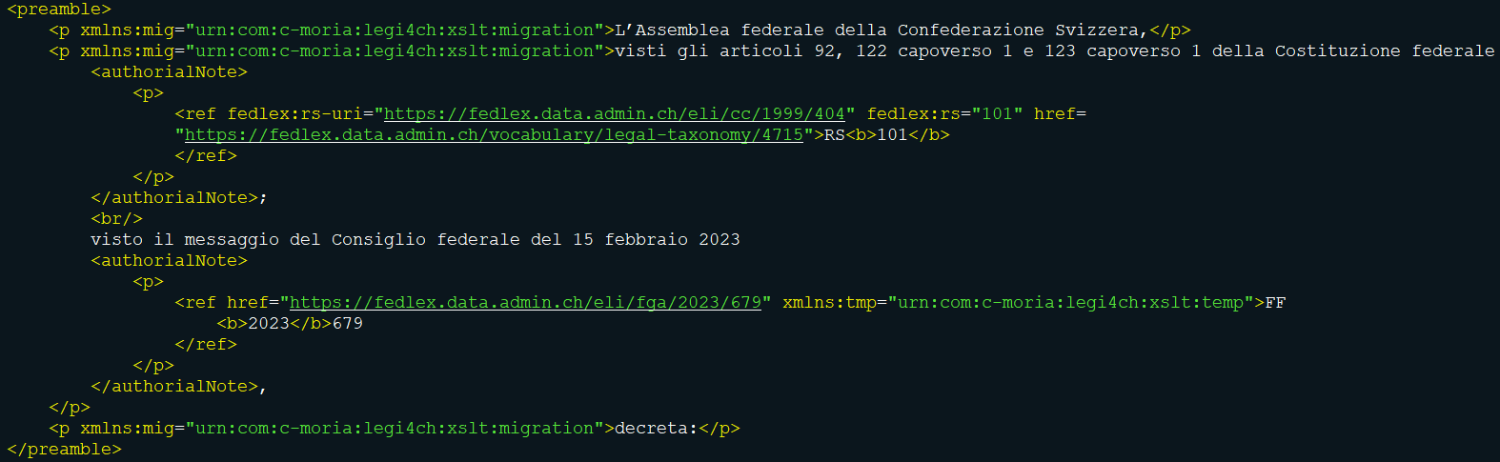
The <preamble> is mandatory structure element for the file to be a valid Akoma Ntoso xml.

The main content: <body>
The main content includes any matter found after the <preamble> up to the <conclusion>, or <attachments>, or the end of the document. It contains the main part of the document, which is characterised by a structural complexity that may vary depending on the document typology and purpose.
It is usually articulated in hierarchical structures in which the text is subdivided into higher subdivisions, basic units and lower subdivisions.
The higher subdivision may be called parts, sections, chapter etc. and groups the basic units. Higher subdivision may have Roman or Arabic numbers or letters to identify them and may or may not have a title. For CH usually titles and numbering.
The basic units (e.g. articles, clauses) may or may not have heading and may be numbered (Roman or Arabic numbers or letters) with a single numeration for the entire body or within each of the parts of which they may be composed of. For CH according to publication guidelines of the Federal Chancellery with heading and numbered.
The lower subdivision may include paragraphs, sub-paragraphs, sub-points, etc. Single paragraph are usually not numbered or may be numbered with Roman or Arabic numbers or letters with different styling conventions. For CH ususally arabic numbers unless only one paragraph (without numbering).
Normative documents are usually modelled in hierarchical structures. By hierarchical structure we mean a structure organized with higher subdvision that groups basic units and lower subdivisions inside of the basic unit, much like a hierarchy of headings in a word document as heading1, heading2, heading3 and so on. The "hierarchy" in the hierarchy structure is analogous to a typical heading hierarchy in a document.
The Akoma Ntoso standard is neutral with respect to the legal drafting traditions and provides most of the hierarchical elements for modelling the body structure in a very precise way without prescribing any fixed order for the different hierarchical elements. It explicitly supports the following hierarchical containers in alphabetical order: alinea, article, book, chapter, clause, division, hcontainer, indent, level, list, paragraph, part, point, proviso, rule, section, subchapter, subclause, subdivision, sublist, subparagraph, subpart, subrule, subsection, subtitle, title, tome and transitional. For CH: ….
In Akoma Ntoso, the <body> element is a conceptual container that holds the main content and structures of a document, though the specific name of this element varies depending on the document type. For instance, a <debateBody> element is used for debates, a <judgmentBody> for court judgments, and a <mainBody> for general purposes, with each providing a specific set of structures for that type of content. The goal is to provide human and machine-readable models for different document types while maintaining a common basic structure.
Purpose and Function of the <body/> (Generic Concept):
- Content Container: the concept of a "body" element in AKN serves as a primary container for the substantive content of a document.
- Document-Specific Structures: the actual name of the body element changes to reflect the document's nature, such as <debateBody>, <judgmentBody>, or <mainBody>.
- Hierarchical Content: the body elements contain the core hierarchical structures and elements that define the content and arguments within a document.
- Structural Elements: these elements are primarily "structural" in nature, meaning they contain other elements rather than direct text content.
- Common Framework: all document types within AKN share common basic structures, providing consistency and facilitating interoperability.
The <body> is mandatory structure element for the file to be a valid Akoma Ntoso xml.
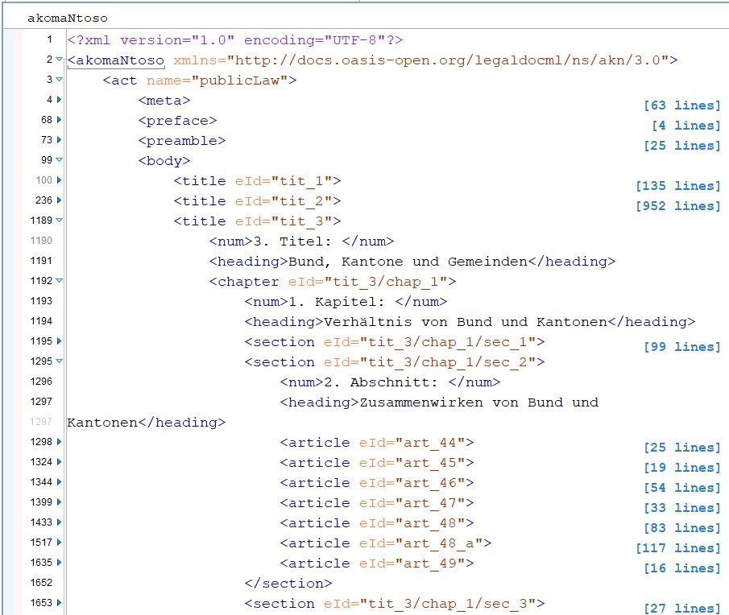
The image below provides an example of the hierarchical organization typical in the body:

As illustrated in the example hierarchy, title elements form the uppermost layer within the body of the document. Nested within a title are chapter elements, and within a chapter, section elements exist. The article elements are positioned at the deepest level of the hierarchy.
There are cases where the hierarchical levels are either not named or their naming is unclear. For instance, in some cases the reference might be simply stated as §7(f)(2), where it is not clear how the lower levels are named. For these undefined or inconsistent cases, the more generic <level> element may be used.

Examples
source | 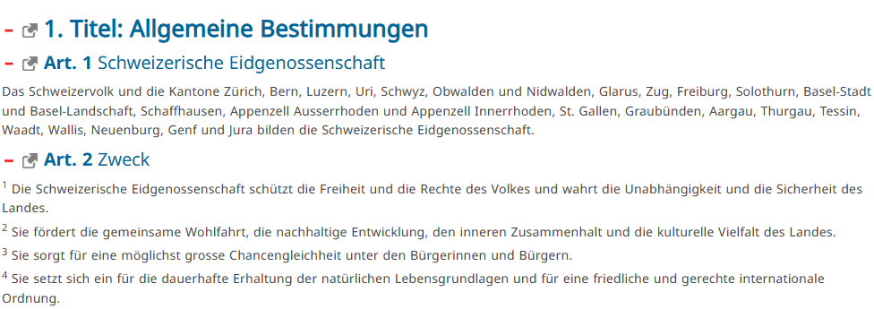
modelling | <body>  <title eId="tit_1">  <num>1. Titel:</num>  <heading>Allgemeine Bestimmungen</heading>  <article eId="art_1">  <num><b>Art. 1</b></num>  <heading>Schweizerische Eidgenossenschaft</heading>  <paragraph eId="art_1/para">  <content>  <p xmlns:mig="urn:com:c-moria:legi4ch:xslt:migration">Das Schweizervolk und die Kantone Zürich, Bern, Luzern, Uri, Schwyz, Obwalden und Nidwalden, Glarus, Zug, Freiburg, Solothurn, Basel-Stadt und Basel-Landschaft, Schaffhausen, Appenzell Ausserrhoden und Appenzell Innerrhoden, St. Gallen, Graubünden, Aargau, Thurgau, Tessin, Waadt, Wallis, Neuenburg, Genf und Jura bilden die Schweizerische Eidgenossenschaft.</p>  </content>  </paragraph>  </article>  <article eId="art_2">  <num><b>Art. 2</b></num>  <heading>Zweck</heading>  <paragraph eId="art_2/para_1">  <num>1</num>  <content>  <p xmlns:mig="urn:com:c-moria:legi4ch:xslt:migration"> Die Schweizerische Eidgenossenschaft schützt die Freiheit und die Rechte des Volkes und wahrt die Unabhängigkeit und die Sicherheit des Landes.</p>  </content>  </paragraph>  <paragraph eId="art_2/para_2">  <num>2</num>  <content>  <p xmlns:mig="urn:com:c-moria:legi4ch:xslt:migration"> Sie fördert die gemeinsame Wohlfahrt, die nachhaltige Entwicklung, den inneren Zusammenhalt und die kulturelle Vielfalt des Landes.</p>  </content>  </paragraph>  <paragraph eId="art_2/para_3">  <num>3</num>  <content>  <p xmlns:mig="urn:com:c-moria:legi4ch:xslt:migration"> Sie sorgt für eine möglichst grosse Chancengleichheit unter den Bürgerinnen und Bürgern.</p>  </content>  </paragraph>  <paragraph eId="art_2/para_4">  <num>4</num>  <content>  <p xmlns:mig="urn:com:c-moria:legi4ch:xslt:migration"> Sie setzt sich ein für die dauerhafte Erhaltung der natürlichen Lebensgrundlagen und für eine friedliche und gerechte internationale Ordnung.</p>  </content>  </paragraph>  </article>
source | 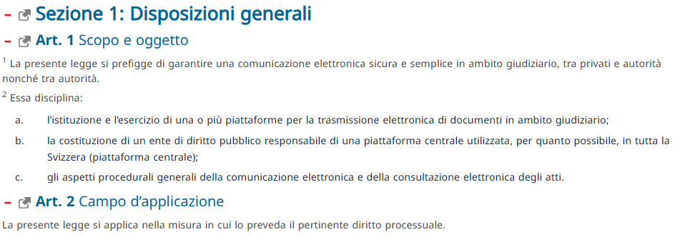
modelling | <body>  <section eId="sec_1">  <num>Sezione 1:</num>  <heading>Disposizioni generali</heading>  <article eId="art_1">  <num><b>Art. 1</b></num>  <heading>Scopo e oggetto</heading>  <paragraph eId="art_1/para_1">  <num>1</num>  <content>  <p xmlns:mig="urn:com:c-moria:legi4ch:xslt:migration"> La presente legge si prefigge di garantire una comunicazione elettronica sicura e semplice in ambito giudiziario, tra privati e autorità nonché tra autorità.</p>  </content>  </paragraph>  <paragraph eId="art_1/para_2">  <num>2</num>  <content>  <blockList>  <listIntroduction eId="art_1/para_2/listintro" xmlns:mig="urn:com:c-moria:legi4ch:xslt:migration"> Essa disciplina:</listIntroduction>  <item eId="art_1/para_2/lbl_a">  <num xmlns:mig="urn:com:c-moria:legi4ch:xslt:migration">a.</num>  <p xmlns:mig="urn:com:c-moria:legi4ch:xslt:migration">l’istituzione e l’esercizio di una o più piattaforme per la trasmissione elettronica di documenti in ambito giudiziario;</p>  </item>  <item eId="art_1/para_2/lbl_b">  <num xmlns:mig="urn:com:c-moria:legi4ch:xslt:migration">b.</num>  <p xmlns:mig="urn:com:c-moria:legi4ch:xslt:migration">la costituzione di un ente di diritto pubblico responsabile di una piattaforma centrale utilizzata, per quanto possibile, in tutta la Svizzera (piattaforma centrale);</p>  </item>  <item eId="art_1/para_2/lbl_c">  <num xmlns:mig="urn:com:c-moria:legi4ch:xslt:migration">c.</num>  <p xmlns:mig="urn:com:c-moria:legi4ch:xslt:migration">gli aspetti procedurali generali della comunicazione elettronica e della consultazione elettronica degli atti.</p>  </item>  </blockList>  </content>  </paragraph>  </article>  <article eId="art_2">  <num><b>Art. 2</b></num>  <heading>Campo d’applicazione</heading>  <paragraph eId="art_2/para">  <content>  <p xmlns:mig="urn:com:c-moria:legi4ch:xslt:migration">La presente legge si applica nella misura in cui lo preveda il pertinente diritto processuale.</p>  </content>  </paragraph>  </article>  </section>

Closing formula: <conclusion>
The closing formula includes all concluding material (e.g. closing formula(s), date(s) and signature(s)) and is placed at the end of the main document, typically before the Annexes.
Some or all the info parts below, not necessarily in the same order, may be found in this part:
- date of execution
- place/site
- witnessing clause
- parties

Example
source | 
modelling | 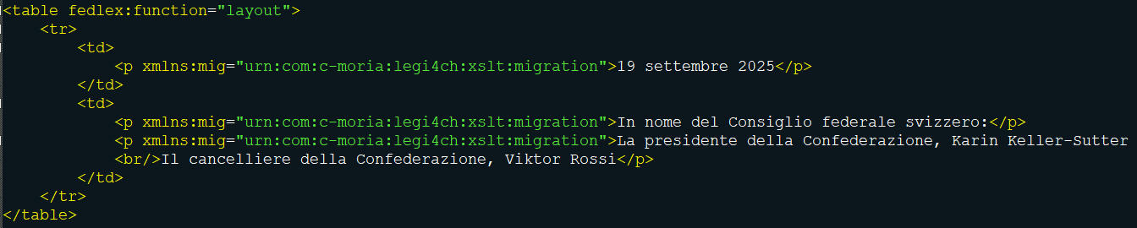

Annexes: <attachments> or <components>
The <components> element (optional) in AKN4CH Akoma Ntoso is a closing XML tag designed to encapsulate all concluding information, such as the signature, date, place, and registration details. The element is placed at the end of the main document body, typically just before the start of any annexes or appendices, if any. This element can contain the following types of information, although the elements and their order may vary:
- Signature of Judges: The signatures of the judges who presided over the case.
- Date and Place: The date and location where the judgment was issued.
- Date Registered: The date the judgment was officially registered.
- Registrar: Information about the registrar who handled the case.
- Original Version: Details about the original language version of the document.
- Other Details: Any other concluding material relevant to the specific document.
The Components is not mandatory element for the file to be a valid Akoma Ntoso xml.

Example
source | 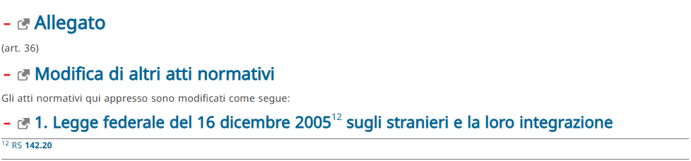
modelling | 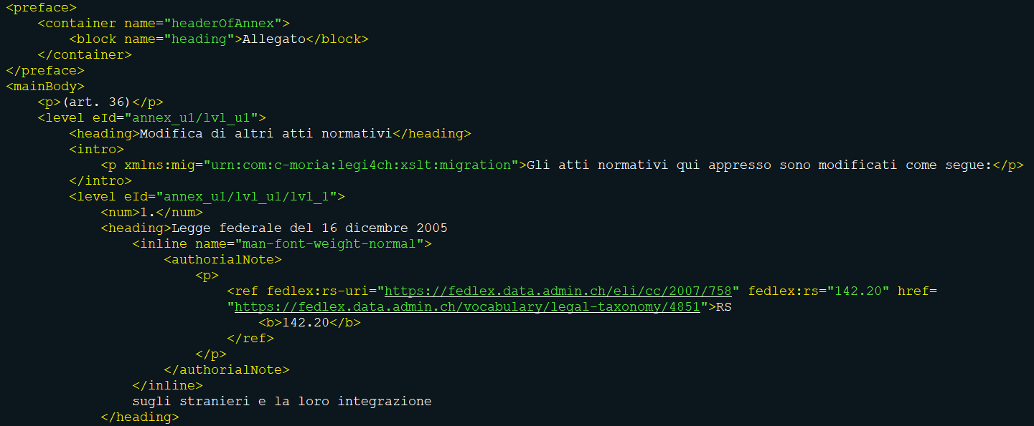
The annexes block includes all additional material in normative documents. They are generally autonomous documents that the normative document adopts or endorses. They all retain their independent structure and formats. When such a document appears after the closing formula, it is structurally considered an annex.
The "additional material" typically appears after the main text of the normative document and may be titled with the word Annex, Attachment, Schedule, Tables, etc. and, usually, a descriptive heading and are used as a means of presenting provisions or parts of provisions separately from the body of the enacting terms, in particular because of their technical nature.

AKN TAGGING FOR STRUCTURAL BLOCKS

Metadata
The FRBR model offers an excellent framework to deal with legal texts. In legal domain, we’ve a lot of derivations due to the constant amendments of normative acts.
Akoma Ntoso makes careful use of the FRBR hierarchy of document definitions: a legal document (such as an act), which may assume different content after being revised and amended, is nonetheless a single work - which gets multiple expressions whenever some specific content is generated (for instance, through an amendment). Each of these expressions has the chance of then being expressed in some electronic form (as a PDF document, or an HTML document, or, in our case, as a specific XML document using vocabulary and grammar from the Akoma Ntoso markup language) thereby generating at least one manifestation. Each physical file where the manifestation is located is therefore an item.
Besides the FRBR levels, an identifier must conform to the URI/IRI syntax and the Akoma Ntoso Naming Convention. While defining a URI/IRI it is important to define:
- 1. the country,
- 2. the type of the document,
- 3. the date of the document and, where applicable, also the version,
- 4. the main language, and also
- 5. the different parts like annexes, exhibits, table, etc.
The metadata within the XML document is intentionally kept to the essentials.
The image below displays the metadata structure for Work, Expression, and Manifestation, along with the necessary references to show the details mentioned above:
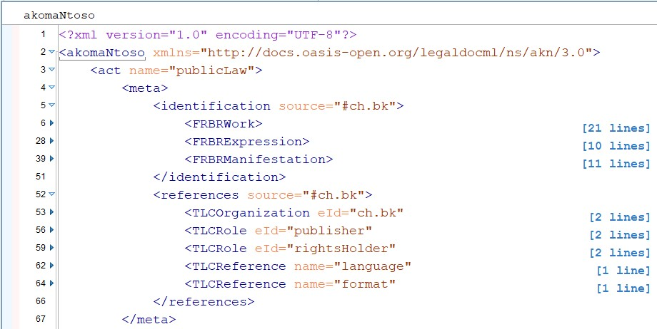
The Fedlex platform extends beyond simple data storage, utilizing an advanced knowledge graph to manage a document's comprehensive metadata. This includes lifecycle stages, chronological records, citations, and more. Take, for example, the publication page of SR 101. It serves as a practical reference for the kind of metadata that is available.
The Akoma Ntoso metadata section provides a separate place for enriching a document with metadata, a place that is clearly identified as such and is dated and authored differently than the content of the text itself.
The metadata elements of Akoma Ntoso are organized in a block called <meta> and inside we find few main sections:
identification: | containing all relevant facts about document, dates and authors.  This block also includes translation information when the document is derived by other languages and properties such as the prescriptiveness of the document and the authoritativeness.
publication: | publication metadata
classification: | keyword classification
lifecycle: | list of the events that modify the document.
workflow: | list of the procedural steps necessary for delivery of the document or that have some role in the legislative process.
analysis: | list of the qualification of the provisions and assertions on the text.
temporalData | list of temporal parameters as a set of events (e.g. time intervals of enter into force and time of efficacy).
references: | list of the external resources connected with the document as well as of all individuals, organizations, and concepts that are relevant to understanding the content and the history of the document.
notes: | annotations inserted by the editor or by the author to explain and detail the text content of the document
proprietary: | local and proprietary metadata
Presentation | specifications of metadata useful for assisting with the document rendering.

To preserve the integrity and consistency of information, especially in how documents interrelate, redundancy is avoided by not replicating this metadata within the XML documents themselves. This practice ensures that each document, whether downloaded as XML, MS Word (docx), or PDF, remains consistent and true to the original text.
For users interested in the full richness of information contained in the legal texts, there is a dedicated SPARQL endpoint available. It allows for in-depth queries against the extensive metadata held within the knowledge graph, providing a comprehensive understanding of the text's context and connections.
By streamlining the metadata directly within the XML documents and offering robust query capabilities through the SPARQL endpoint, users are afforded a balance between document fidelity and rich metadata access.
The Fedlex publishing process involves an automated transformation of documents from their original MS Word format to the XML format used for publication. To ensure that any feedback can be accurately addressed, the version information of the transformation tool is included within the Manifestation metadata of the XML document. This inclusion allows for precise tracing and improvements specific to the version of the tool used.
This information is captured as an extension attribute within the Fedlex namespace. This guide demonstrates how extension attributes are used inside the Fedlex information model. Extensions attributes are used sparsely, and the permitted attribute names and values are restricted by rules. [FLX-XF-001]
The following image shows how this attribute is structured within the metadata:
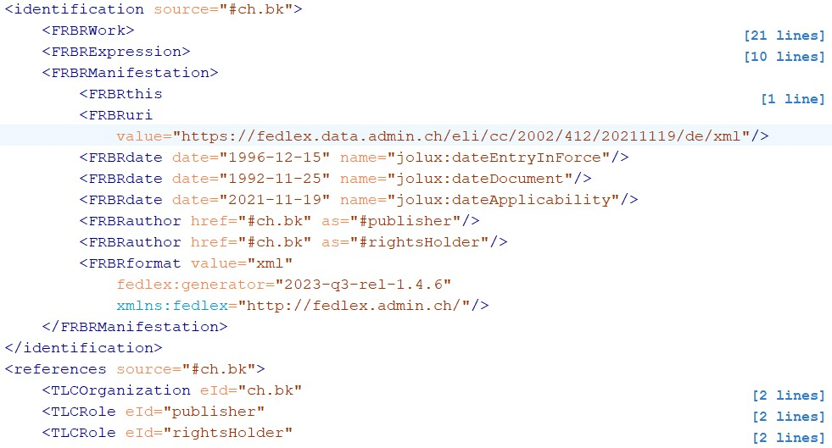
By embedding the generator version details directly into the document's metadata, a clear audit trail for the transformation process exists, enabling the management of document quality and the effective response to user feedback. [FLX-XF-002]¹⁴
Each level of this hierarchy can be identified by a number (num) and may also include a title (heading). When both are used, the numbering will precede the title. [FLX-HD-002]¹⁴
A num is optional, but cannot appear more than once in a hierarchical container. [FLX-HD-001]¹⁴
Also a heading is optional, and cannot appear more than once in a hierarchical container. [FLX-HD-004]¹⁴
Occasionally a hierarchical container can have a subheading. When present, a subheading will be preceded by the optional num and/or heading. [FLX-HD-003] [FLX-HD-005]15
A subheading is optional but cannot appear more than once in a hierarchical container. [FLX-HD-006]
As a subheading often has a referential characteristic, it has the possibility to carry an extension attribute role in the Fedlex namespace, with the value “reference”. Note that this attribute with value “reference” is only allowed on subheading elements. [FLX-XF-005]¹⁵
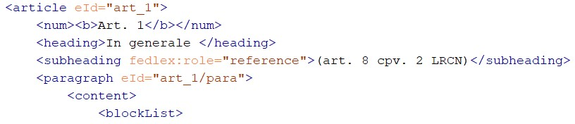
The below image shows an example of a subheading with referential characteristic in use. (example taken from RS 732.441)

Shared elements
Other elements inline are shared by all the types of documents:
<date> | The date element permits marking up any date in the text and associating a particular meaning using the refersTo attribute. <date date="2013-04-04" refersTo="#signatureDate">four April 2013</date> or to specify the time and zone <date date="2013-04-04T12:00:00" refersTo="#signatureDate">four April 2013</date>. The attribute date is used to give a normalized value for a date according to the XSD syntax YYYY-MM-DD or a normalized value for a dateTime according to the XSD syntax YYYY-MM-DDThh:mm:ss(zzzz)
<time> | The time element is an inline element to identify a time expressed in the text and to propose a normalized representation in the time attribute.
<person> | The person element is an inline element to identify a person expressed in the text and connect he/she to the ontological class.
<organization> | The organization element is an inline element to identify an organization expressed in the text and connect it to the ontological class.
<concept> | The concept element is an inline element to identify a concept expressed in the text and connect it to the ontological class.
<object> | The object element is an inline element to identify an object expressed in the text and to connect it to the ontological class.
<event> | The event element is an inline element to identify an event (e.g. All Saints, EasterMonday) expressed in the text and to connect it to the ontological class.
<location> | The location element is an inline element to identify a location (e.g. Bern, Federal Building) expressed in the text and connect it to the ontological class.
<process> | The process element is an inline element to identify a process (e.g. voting of the bill) expressed in the text and to connect it to the ontological class.
<role> | The role element is an inline element to identify a role (e.g. member of assembly, secretary, president, judge, solicitor, etc.) expressed in the text and connect it to the ontological class.
<term> | The term element is an inline element to identify a term (e.g. privacy, IPR, etc.) expressed in the text and to connect it to the ontological class.
<quantity> | The quantity element quantity is an inline element to identify a quantity (e.g. 20 attendees, IPR, etc.) expressed in the text and to connect it to the ontological class.
<def> | The def element is an inline element to identify a definition (e.g. “stalking” is defined as...) expressed in the text and to connect it to the ontological class.
<entity> | The entity element is an inline element to identify an entity expressed in the text and to connect it to the ontological class.

Element borrowed from HTML
Name of the element | Group in Akoma Ntoso | Description
<div> | HTML containers | The element <div> is an HTML element but is NOT used as in HTML. Instead of being used as a generic block, Akoma Ntoso uses <div> as a generic container to define a container not included in the regular vocabulary.
<p> | HTML block | The element <p> is an HTML element used as in HTML, for the generic paragraph of text (a block).
<ul> / <ol> | HTML block | The elements <ul>/<ol> are HTML elements for defining unnumbered or numbered list.
<li> | HTML block | The element <li> is an HTML item of <ul> or <ol>.
<table> | HTML block | The element <table> is HTML element to define a table.
<th> / <tr> / <td> / <caption> | HTML block | The elements <th>/<tr>/<td>/<caption> are HTML elements of the table.
<span> | HTML inline | The element <span> is an HTML element used as in HTML, for the generic inline.
<b> | HTML inline | The element b is an HTML element used as in HTML, for indicating bold style.
<i> | HTML inline | The element i is an HTML element used as in HTML, for indicating italic style.
<a> | HTML inline | The element a is an HTML element used as in HTML, for indicating a link to hypertext resources.
<u> | HTML inline | The element u is an HTML element used as in HTML, for indicating underline style.
<sub> | HTML inline | The element sub is an HTML element used as in HTML, for indicating text as subscripts.
<sup> | HTML inline | The element sup is an HTML element used as in HTML, for indicating text as superscripts.
<abbr> | HTML inline | Sometime the act is named with an abbreviation. Akoma Ntoso manages abbreviation using the element <abbr> (e.g. LCR for the "Loi fédérale sur la circulation routière").
<br> | HTML marker | It is the line break used in the HTML definition.
<img> | HTML marker | It is used as pointer for declaring the position where to embed an image in the XML manifestation.
<eop> / <eol> | HTML marker | These are used to identify the end of page (and also end of line) as markers by their mere presence at a given position. Therefore, they are placed nearest to the end of the page and line according to the reference copy in printed form. There is the assumption that the corresponding beginning of page and line are immediately after the previous <eop> and <eol>.

Identification – IRI (Normative) vs. ELI

Introduction to compliant IRI syntaxes
The Akoma Ntoso standard defines a number of referenceable concepts used in many situations in the lifecycle of legal documents. The purpose of this section is to provide:
a) a standard referencing mechanism to these concepts through the use of IRI (Internationalized Resource Identifier) references associated to classes and instances of an ad hoc ontology (the Akoma Notoso Naming Convention).
b) a set of requirements for other naming conventions to be usable within Akoma Ntoso XML resources in a proper way (Functionally Equivalent Naming Conventions - FENC).

European Legislation Identifier (ELI)
ELI/XML is an encoding of ELI metadata in an XML schema (XSD). It can be used standalone or imported into other XML documents, typically in a metadata header. The ELI/XML schema is provided with a set of XML transformations to generate ELI in RDF/XML, RDFa header or HTML+RDFa. It is meant to facilitate the integration of ELI in XML-based document workflows.

Fedlex Naming Convention
Fedlex naming conventions are based on the ELI standard, which provides a structured naming scheme for federal legal resources like laws, compilations, and treaties. The convention uses unique URIs (Uniform Resource Identifiers) to identify specific legal documents and their versions. Components of the naming convention
- Collection type (identifies the type of legal document):
  - fga: Federal Gazette
  - oc: Official Compilation
  - cc: Classified Compilation
  - cons: Consultation procedures
  - treaty: International treaties
- Unique identifiers: Each document has a unique numerical identifier within its collection, such as RS 832.202 for a Classified Compilation entry whose reference for the Official collection would be RO 199 2879. This document is not yet in xml format.
- Versioning: The URIs can specify a particular version of a document, reflecting changes over time. The dates are handled within the ontology as FRBR dates such as jolux:dateApplicability, jolux:dateEntryInForce, jolux:datedocument in all the sections of <FRBRWork>, <FRBRExpression> and <FRBRManifestation>.
Values for the 2021 version | Values for the 2024 version
<FRBRdate date="2000-01-01" name="jolux:dateEntryInForce"/> | <FRBRdate date="2000-01-01" name="jolux:dateEntryInForce"/>
<FRBRdate date="1999-04-18" name="jolux:dateDocument"/> | <FRBRdate date="1999-04-18" name="jolux:dateDocument"/>
<FRBRdate date="2021-01-01" name="jolux:dateApplicability"/> | <FRBRdate date="2024-03-03" name="jolux:dateApplicability"/>
- Citations: References to other documents are structured to link directly from the citing article to the cited article.

Microstructure

Micro-structure elements
For hierarchical structure we mean a structure organized with higher levels that group basic units, basic units (article, section, etc.) and lower levels inside of the basic unit.
The Akoma Ntoso standard is neutral with respect to the legal drafting techniques of the different legal traditions, providing most of the hierarchical elements for modelling the body structure: book, tome, part, subpart, title, subtitle, chapter, subchapter, section, subsection, clause, subclause, paragraph, subparagraph, division, point, indent, alinea, list, sublist.
For these reasons, the main requirements of structuring legal text are covered.
The following table shows an example use of hierarchical elements:
 | Swiss tradition | Akoma Ntoso | Used in AKN4CH
Higher Division |  | Tome | No
 | Part/Partie | Part | No
 | Livre | Book | Yes
 | Title/Titre | Title | Yes
 | Chapter/Chapitre | Chapter | Yes
 | Section/section/ | Section | Yes
 | Subsection/Sous-Section | Subsection | Yes
 |  | Level | Yes
Basic Unit | Article (rule)/article | article/section/rule | Yes
Subdivision | unnumbered paragraph/alinéa | Subsection/Alinea/clause | Yes
 | Paragraph/paragraphe | Paragraph | Yes
 |  | Proviso | Yes
 | Subparagraph/sous paragraphe | Subparagraph | No
 |  | Division | Yes
 | Point/point/ | point/item | Yes

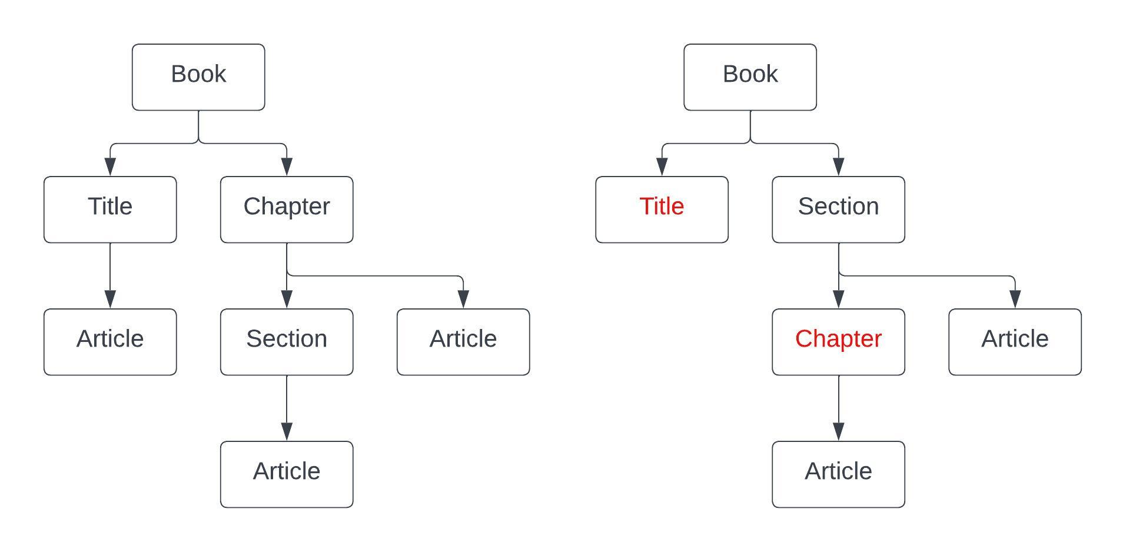
This more restrictive and specific organization ensures that the structure of Swiss Federal law is both consistent and logically ordered, following the specific guidelines of the Fedlex Information Model. [FLX-HR-001-xx]
Table 1 expresses these rules for direct or indirect containment.
Can directly or indirectly contain | book | title | part | chapter | sub-chapter | section | Sub-section | article
Book |  | X | X | X | X | X | X | X
title | X |  | X | X | X | X | X | X
part |  |  |  | X | X | X | X | X
chapter |  |  |  |  | X | X | X | X
subchapter |  |  |  |  |  | X | X | X
section |  |  |  |  |  |  | X | X
subsection |  |  |  |  |  |  |  | X
article

Any of the hierarchical component types shown in the table above, have the possibility to appear as the top level element in the body of an act. [FLX-BD-001]
Swiss legislative practice maintains a disciplined approach to structuring legal texts. Notably, it is not allowed to house more than 10 legal articles within a single hierarchical container. If a situation arises where an 11th article is introduced into a chapter, the structure is then refined by introducing a section as an intermediary level to maintain clarity and navigability.
The Fedlex Information Model accommodates the inclusion of generic level containers at any stage in the document hierarchy. This flexibility allows for the integration of these components alongside the more precisely defined hierarchical structure as detailed earlier. [FLX-XF-004]21
In regard to direct and indirect containment rules, generic levels should be perceived as 'transparent.' A <level> element possesses the capability to function as a child element to any hierarchical component outlined in the Information Model. However, the permissibility of child elements within a level element is dictated by its ancestors. [FLX-HR-001-lv]21
Note that all hierarchical elements should have a unique identifier by means of an eId attribute. [FLX-HR-002-xx]

Special hierarchical constructs

Proviso (final disposition or final provision)
A proviso represents a specific type of article, typically positioned towards the end of a legislative text. A text can have multiple proviso, potentially intermixed with transitional (as will be discussed later). Structurally, a proviso is similar to an article in terms of content. However, an article has a mandatory num. A proviso in general is not numbered.
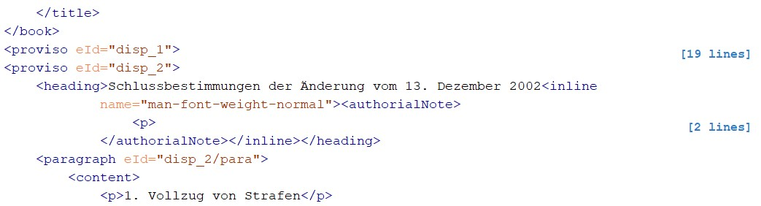
The image below presents an example of how a proviso is incorporated within the context of the legislative text:
This example illustrates the practical application of a proviso and its positioning within the document, providing clarity on its usage and differentiation from standard articles.

Transitional (disposition or provision)
Transitional are distinct elements within a legal text, typically positioned towards the end of a legislative text. It is not unusual for a document to contain several transitional provisions, which may be interspersed among provisos. For example …
Structurally, a <transitional> element is similar to an <article> element in terms of content. Contrary to the first, an article has a mandatory number represented by the <num> element.
The following image provides a clear example of how transitional provisions are integrated within the broader context of a legislative document:
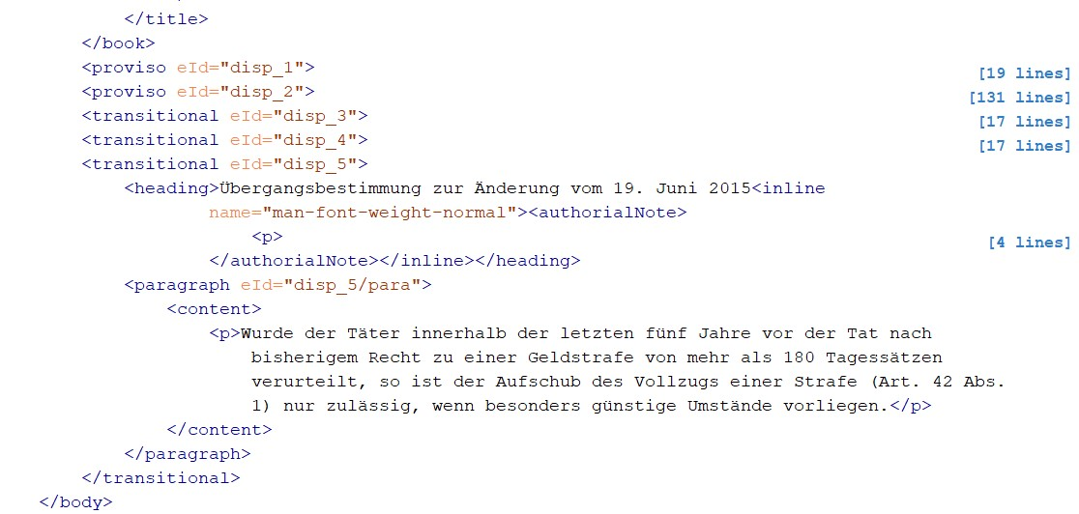
This example illustrates the practical application of a transitional and its positioning within the document, providing clarity on its usage and differentiation from standard articles.

Article content
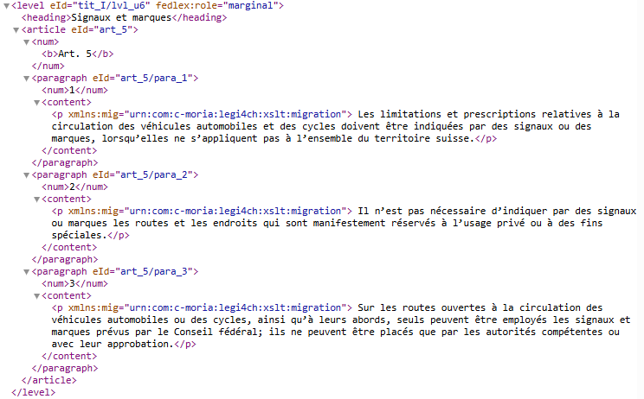
In legislative texts, in a conceptual sense, an article serves as a terminal point in the document's hierarchy. Its content is encapsulated within its paragraph child elements.

Paragraphs
Each article has a mandatory numerical label (<num>) and may also feature a heading (<heading>). [FLX-ART-001] When both are present, the numbering should precede the heading. [FLX-HD-002]23 As with other hierarchical constructs, an article can have a subheading that can only appear after the mandatory num and the optional heading. [FLX-HD-003]23
Within the main text of an act, article numbers are unique. However, there is an exception: if an act includes a “final title” — a single title element that is marked as ‘final’ — then the article numbering would recommence inside that “final title”.
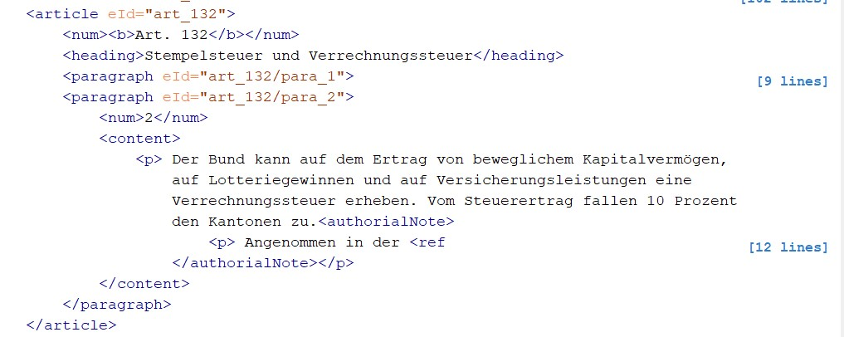
The image below shows how content is organized within an article, showing the relationship between the article and its legal paragraph children:

A paragraph can only appear in the context of an article (or a subdivision). [FLX-PR-002] and can have a num, a heading and a subheading (rules are as specified with hierarchical components) and also a content element. [FLX-PR-001]24 A paragraph requires a unique identifier by means of an eId attribute. [FLX-PR-003]24
Occasionally, paragraphs may require additional grouping, which could involve an intertitle. In such instances, a subdivision element is used to provide this structure. [FLX-SD-001]24
A subdivision can only appear in the context of an article. [FLX-SD-002]24 and requires a unique identifier by means of an eId attribute. [FLX-SD-003]24
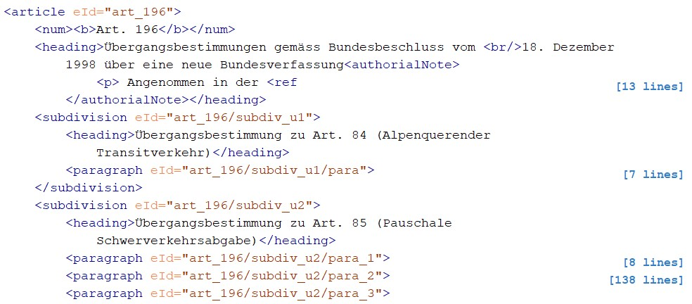
The following image depicts an example of an article that incorporates such subdivisions:

Lists
A paragraph can contain one or more lists that can contain each one or more lists. If a list is in the <preamble> it must be marked up as <blocklist>.
From the Akoma Ntoso perspective, it was decided to use <blocklist> instead of <list>, as it would be easier for the management of complex textual and legal structures.
In Akoma Ntoso, the difference between the two types of lists lies in their intended semantic structure, content model and similarity with HTML elements:
- <blocklist> is designed specifically for complex legal texts, aften acting as container for numbered or lettered paragraphs (<items>) that include block-level content.
  - The purpose of a blocklist is to be used for lists or items that contain complex, structured content within each item, such as a set of paragraphs, sub-paragraphs or enumerated statements.
  - Structurally, the <blocklist> is a container that holds a list of <item> which in turn can contain block-level elements like paragraphs (<p>), images, tables or nested lists.
- <list> is more akin to the simpler HTML unordered (<ul>) or ordered (<ol>) lists.
  - The purpose of a list is to be used for simpler lists. The <list> is a simple container composed by <item> elements. The structure of a list item is more strict, compared to the one of a <blocklist> item.

Examples
For AKN4CH it was decided to use <blocklists> for all kind of lists. Lists do not always have an introductory sentence:
source | 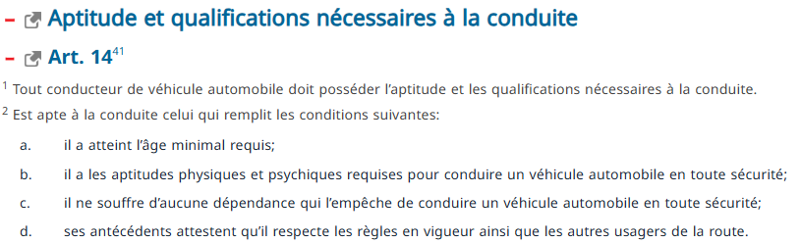
modelling | 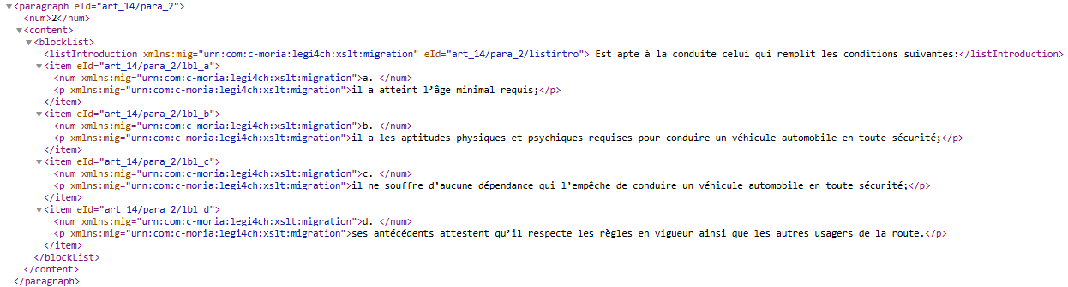
An example of second level lists:
source36 | 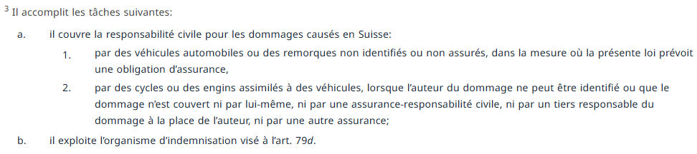
modelling | 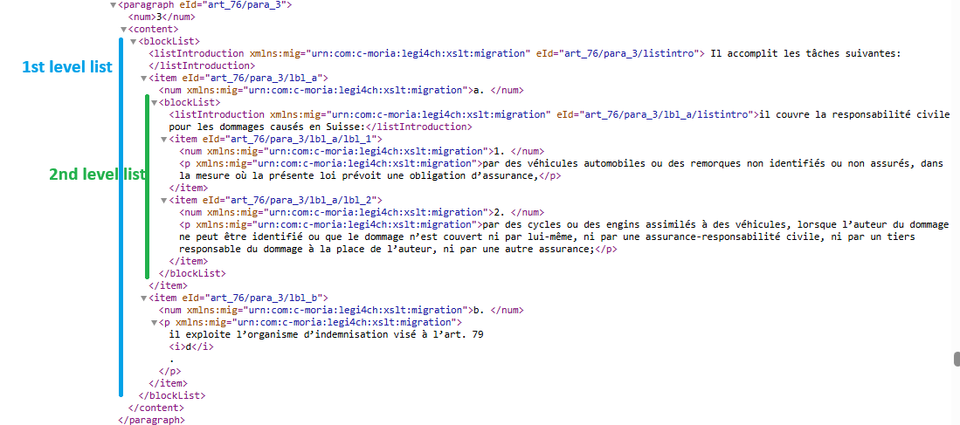
An example of a third level list:
source | 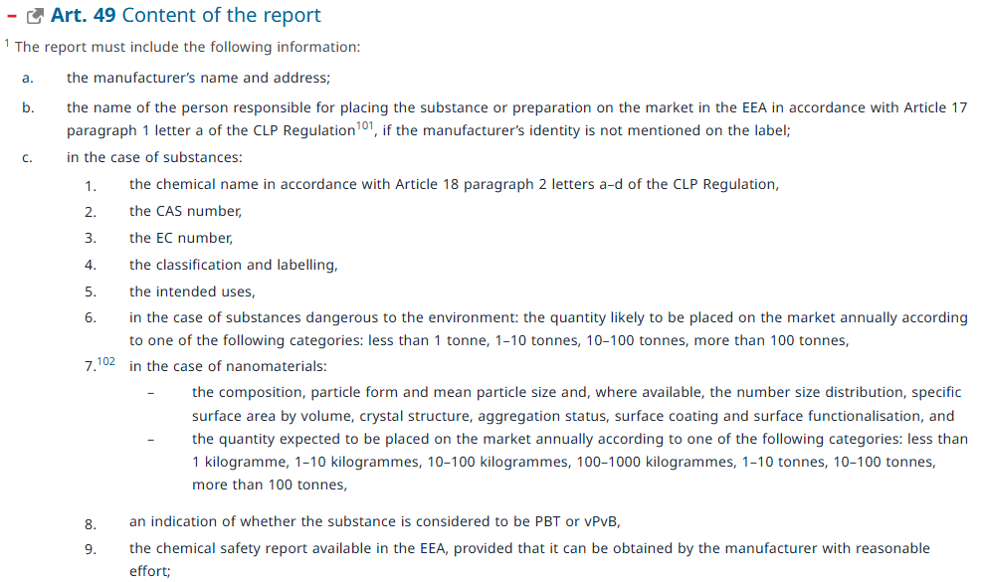
modelling | <article eId="art_49">  <num><b>Art. 49</b></num>  <heading>Content of the report</heading>  <paragraph eId="art_49/para_1">  <num>1</num>  <content>  <blockList>  <listIntroduction xmlns:mig="urn:com:c-moria:legi4ch:xslt:migration" eId="art_49/para_1/listintro"> The report must include the following information:</listIntroduction>  <item eId="art_49/para_1/lbl_a">  <num xmlns:mig="urn:com:c-moria:legi4ch:xslt:migration">a. </num>  <p xmlns:mig="urn:com:c-moria:legi4ch:xslt:migration">the manufacturer’s name and address;</p></item>  <item eId="art_49/para_1/lbl_b">  <num xmlns:mig="urn:com:c-moria:legi4ch:xslt:migration">b. </num>  <p xmlns:mig="urn:com:c-moria:legi4ch:xslt:migration">  the name of the person responsible for placing the substance or preparation on the market in the EEA in accordance with Article 17 paragraph 1 letter a of the CLP Regulation<authorialNote><p> See footnote to Art. 2 para. 4.</p>  </authorialNote>, if the manufacturer’s identity is not mentioned on the label;  </p></item>  <item eId="art_49/para_1/lbl_c”>  <num xmlns:mig="urn:com:c-moria:legi4ch:xslt:migration">c. </num>  <blockList>  <listIntroduction xmlns:mig="urn:com:c-moria:legi4ch:xslt:migration" eId="art_49/para_1/lbl_c/listintro">in the case of substances:</listIntroduction>  <item eId="art_49/para_1/lbl_c/lbl_1">  <num xmlns:mig="urn:com:c-moria:legi4ch:xslt:migration">1. </num>  <p xmlns:mig="urn:com:c-moria:legi4ch:xslt:migration">the chemical name in accordance with Article 18 paragraph 2 letters a–d of the CLP Regulation,</p></item>  <item eId="art_49/para_1/lbl_c/lbl_2">  <num xmlns:mig="urn:com:c-moria:legi4ch:xslt:migration">2. </num>  <p xmlns:mig="urn:com:c-moria:legi4ch:xslt:migration">the CAS number,</p>  </item>  <item eId="art_49/para_1/lbl_c/lbl_3">  <num xmlns:mig="urn:com:c-moria:legi4ch:xslt:migration">3. </num>  <p xmlns:mig="urn:com:c-moria:legi4ch:xslt:migration">the EC number,</p></item>  <item eId="art_49/para_1/lbl_c/lbl_4">  <num xmlns:mig="urn:com:c-moria:legi4ch:xslt:migration">4. </num>  <p xmlns:mig="urn:com:c-moria:legi4ch:xslt:migration">the classification and labelling,</p></item>  <item eId="art_49/para_1/lbl_c/lbl_5">  <num xmlns:mig="urn:com:c-moria:legi4ch:xslt:migration">5. </num>  <p xmlns:mig="urn:com:c-moria:legi4ch:xslt:migration">the intended uses,</p></item>  <item eId="art_49/para_1/lbl_c/lbl_6">  <num xmlns:mig="urn:com:c-moria:legi4ch:xslt:migration">6. </num>  <p xmlns:mig="urn:com:c-moria:legi4ch:xslt:migration">in the case of substances dangerous to the environment: the quantity likely to be placed on the market annually according to one of the following categories: less than 1 tonne, 1–10 tonnes, 10–100 tonnes, more than 100 tonnes,</p></item>  <item eId="art_49/para_1/lbl_c/lbl_7">  <num xmlns:mig="urn:com:c-moria:legi4ch:xslt:migration">7.<authorialNote><p>Amended by No I of the O of 31 Jan. 2018, in force since 1 March 2018 (<ref href="https://fedlex.data.admin.ch/eli/oc/2018/102">AS<b>2018</b>801</ref>).</p></authorialNote>  </num>  <blockList>  <listIntroduction xmlns:mig="urn:com:c-moria:legi4ch:xslt:migration" eId="art_49/para_1/lbl_c/lbl_7/listintro">in the case of nanomaterials:</listIntroduction>  <item eId="art_49/para_1/lbl_c/lbl_7/bull_u1">  <num>– </num>  <p>the composition, particle form and mean particle size and, where available, the number size distribution, specific surface area by volume, crystal structure, aggregation status, surface coating and surface functionalisation, and</p></item>  <item eId="art_49/para_1/lbl_c/lbl_7/bull_u2">  <num>– </num>  <p>the quantity expected to be placed on the market annually according to one of the following categories: less than 1 kilogramme, 1–10 kilogrammes, 10–100 kilogrammes, 100–1000 kilogrammes, 1–10 tonnes, 10–100 tonnes, more than 100 tonnes,</p></item>  </blockList>  </item>  <item eId="art_49/para_1/lbl_c/lbl_8">  <num xmlns:mig="urn:com:c-moria:legi4ch:xslt:migration">8. </num>  <p xmlns:mig="urn:com:c-moria:legi4ch:xslt:migration">an indication of whether the substance is considered to be PBT or vPvB,</p></item>  <item eId="art_49/para_1/lbl_c/lbl_9”>  <num xmlns:mig="urn:com:c-moria:legi4ch:xslt:migration">9. </num>  <p xmlns:mig="urn:com:c-moria:legi4ch:xslt:migration">the chemical safety report available in the EEA, provided that it can be obtained by the manufacturer with reasonable effort;</p>  </item>  </blockList>  </item>

In the mark-up perform the following checks:
  - All the content has been embedded into a container (paragraph, list, etc).
  - All the list numbers or letters have been marked up as such. If correctly marked up, they usually appear on a different line than the content of the point of the list.

Footnotes
All notes within the document are categorized as authorialNote. This categorization is used predominantly because these notes often contain cross-references to other acts and are maintained inline for coherence. To ensure publications consistency, hard line-breaks within a heading are represented in the model as <br> elements. [FLX-TXT-001]

Example

source | 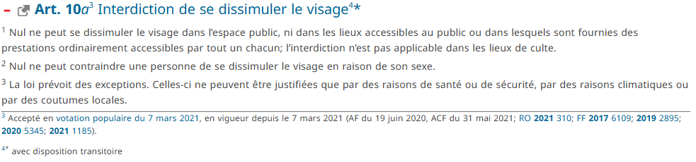
modelling | <article eId="art_10_a">  <num><b>Art. 10</b><i>a</i>  <authorialNote>  <p>Accepté en  <ref href="http://www.admin.ch/ch/f/pore/va/20210307/index.html">votation populaire du 7 mars 2021</ref>, en vigueur depuis le 7 mars 2021 (AF du 19 juin 2020, ACF du 31 mai 2021;<ref href="https://fedlex.data.admin.ch/eli/oc/2021/310">RO<b>2021</b>310</ref>;<ref href="https://fedlex.data.admin.ch/eli/fga/2017/1844">FF<b>2017</b>6109</ref>;<ref href="https://fedlex.data.admin.ch/eli/fga/2019/868"><b>2019</b>2895</ref>;<ref href="https://fedlex.data.admin.ch/eli/fga/2020/1295"><b>2020</b>5345</ref>;<ref href="https://fedlex.data.admin.ch/eli/fga/2021/1185"><b>2021</b>1185</ref>).  </p>  </authorialNote>  </num>  <heading>Interdiction de se dissimuler le visage  <authorialNote>  <p>  <sup xmlns:tmp="urn:com:c-moria:legi4ch:xslt:temp">*</sup> avec disposition transitoire  </p>  </authorialNote>  </heading>  (…)  </article>

Side notes (titre marginal)
Some acts may exhibit deeper levels of hierarchy than those already outlined. Such levels do not carry specific semantic weight. Instead, they are denoted as generic levels. In the printed versions of Swiss legislation, these generic levels are often labelled with marginal notes.
The image below is an excerpt from SR 210. It demonstrates a deeper nesting in practice, with the inclusion of marginal notes to facilitate ease of reading and interpretation.

Example

source36 | 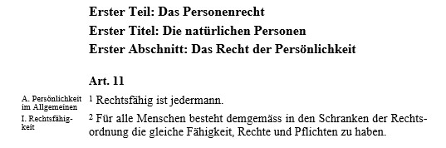
modelling | 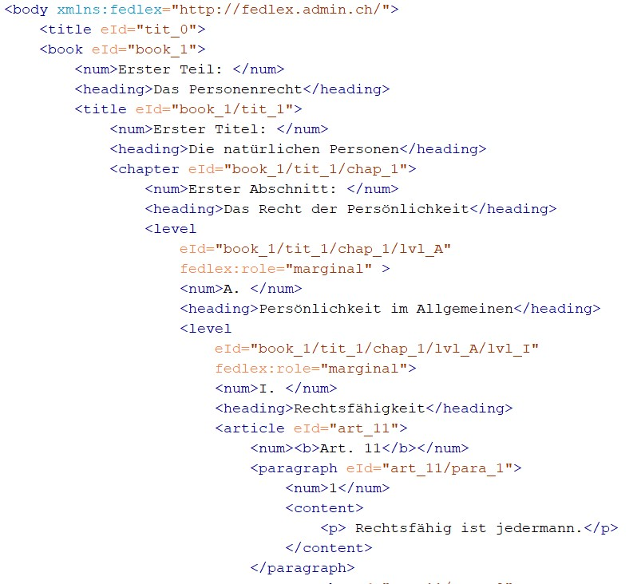

The image illustrates how these generic levels are represented within the Fedlex XML model, including the marginal notes in the printed document that receive a role attribute in the Fedlex namespace, with a value “marginal”. [FLX-XF-003]:
The image below shows this attribute in more detail. Note that this attribute with value “marginal” is only allowed on level elements. [FLX-XF-004]21
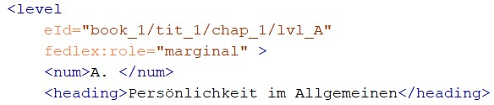

Tables
Akoma Ntoso inherits the markup of tables from the HTML markup language.
A table structure is enclosed in the opening and closing tags <table>, <tr>, <td>.
This said, in the same way as lists, tables can also contain other tables on different levels.

Examples
Below is an example of a simple table, that contains simple text and footnotes:
source | 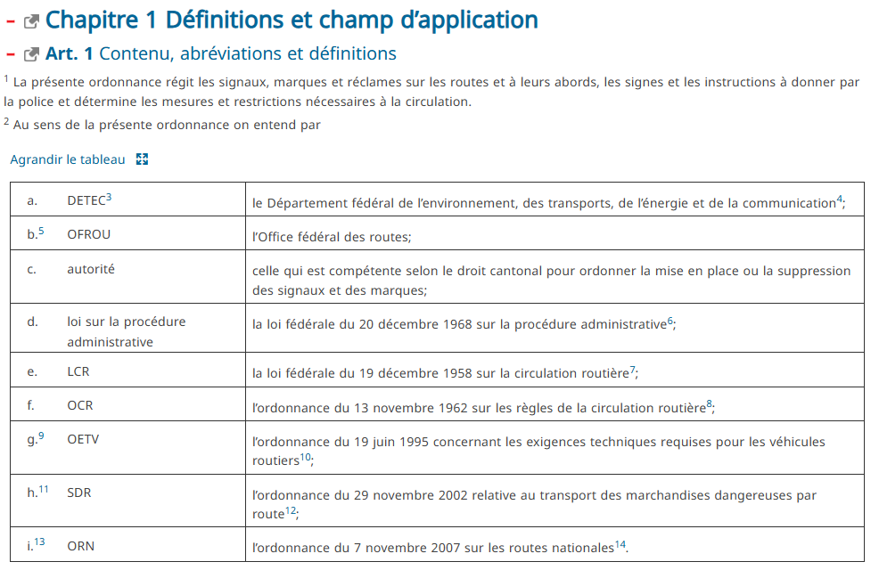
modelling | <chapter eId=“chap_1">  <num>Chapitre 1</num>  <heading>Définitions et champ d’application</heading>  <article eId=“art_1">  <num><b>Art. 1</b></num>  <heading>Contenu, abréviations et définitions</heading>  <paragraph eId=“art_1/para_1">  <num>1</num>  <content><p xmlns:mig=“urn:com:c-moria:legi4ch:xslt:migration"> La présente ordonnance régit les signaux, marques et réclames sur les routes et à leurs abords, les signes et les instructions à donner par la police et détermine les mesures et restrictions nécessaires à la circulation.</p></content>  </paragraph>  <paragraph eId=“art_1/para_2">  <num>2</num>  <content><p xmlns:mig=“urn:com:c-moria:legi4ch:xslt:migration"> Au sens de la présente ordonnance on entend par</p>  <table border="1">  <tr>  <td>  <blockList>  <item>  <num xmlns:mig=“urn:com:c-moria:legi4ch:xslt:migration">a. </num>  <p xmlns:mig=“urn:com:c-moria:legi4ch:xslt:migration">DETEC<authorialNote><p>Nouveau terme selon le ch. I de l’O du 1<sup xmlns:tmp="urn:com:c-moria:legi4ch:xslt:temp">er </sup> avr. 1998, en vigueur depuis le 1<sup xmlns:tmp="urn:com:c-moria:legi4ch:xslt:temp">er</sup> juin 1998 (<ref href="https://fedlex.data.admin.ch/eli/oc/1998/1440_1440_1440">RO<b>1998</b>1440</ref>). Il a été tenu compte de cette mod. dans tout le texte.</p></authorialNote>  </p>  </item>  </blockList>  </td>  <td>  <p xmlns:mig=“urn:com:c-moria:legi4ch:xslt:migration">le Département fédéral de l’environnement, des transports, de l’énergie et de la communication  <authorialNote><p>Nouveau terme selon le ch. I de l’O du 1<sup xmlns:tmp="urn:com:c-moria:legi4ch:xslt:temp">er </sup> avr. 1998, en vigueur depuis le 1<sup xmlns:tmp="urn:com:c-moria:legi4ch:xslt:temp">er</sup> juin 1998 (<ref href="https://fedlex.data.admin.ch/eli/oc/1998/1440_1440_1440">RO<b>1998</b>1440</ref>).</p></authorialNote>;  </p>  </td>  </tr>  <tr>  <td>  <blockList>  <item>  <num xmlns:mig=“urn:com:c-moria:legi4ch:xslt:migration">b. <authorialNote><p>Nouvelle teneur selon le ch. I de l’O du 24 juin 2015, en vigueur depuis le 1<sup xmlns:tmp="urn:com:c-moria:legi4ch:xslt:temp">er</sup> janv. 2016 (<ref href="https://fedlex.data.admin.ch/eli/oc/2015/461">RO<b>2015</b> 2459</ref>).</p></authorialNote>  </num>  <p xmlns:mig=“urn:com:c-moria:legi4ch:xslt:migration">OFROU</p>  </item>  </blockList>  </td>  <td>  <p xmlns:mig=“urn:com:c-moria:legi4ch:xslt:migration">l’Office fédéral des routes;</p>  </td>  </tr>  <tr>  <td>  <blockList>  <item>  <num xmlns:mig=“urn:com:c-moria:legi4ch:xslt:migration">c. </num>  <p xmlns:mig=“urn:com:c-moria:legi4ch:xslt:migration">autorité</p>  </item>  </blockList>  </td>  <td>  <p xmlns:mig=“urn:com:c-moria:legi4ch:xslt:migration">celle qui est compétente selon le droit cantonal pour ordonner la mise en place ou la suppression des signaux et des marques;</p>  </td>  </tr>  <tr>  <td>  <blockList>  <item>  <num xmlns:mig=“urn:com:c-moria:legi4ch:xslt:migration">d. </num>  <p xmlns:mig=“urn:com:c-moria:legi4ch:xslt:migration">loi sur la procédure administrative</p>  </item>  </blockList>  </td>  <td>  <p xmlns:mig=“urn:com:c-moria:legi4ch:xslt:migration">la loi fédérale du 20 décembre 1968 sur la procédure administrative<authorialNote><p><ref fedlex:rs-uri="https://fedlex.data.admin.ch/eli/cc/1969/737_757_755" fedlex:rs="172.021" href="https://fedlex.data.admin.ch/vocabulary/legal-taxonomy/5059">RS<b>172.021</b></ref>  </p></authorialNote>;  </p>  </td>  </tr>  <tr>  <td>  <blockList>  <item>  <num xmlns:mig=“urn:com:c-moria:legi4ch:xslt:migration">e. </num>  <p xmlns:mig=“urn:com:c-moria:legi4ch:xslt:migration">LCR</p>  </item>  </blockList>  </td>  <td>  <p xmlns:mig=“urn:com:c-moria:legi4ch:xslt:migration">la loi fédérale du 19 décembre 1958 sur la circulation routière<authorialNote><p><ref fedlex:rs-uri="https://fedlex.data.admin.ch/eli/cc/1959/679_705_685" fedlex:rs="741.01" href="https://fedlex.data.admin.ch/vocabulary/legal-taxonomy/8613">RS<b>741.01</b></ref>  </p></authorialNote>;  </p>  </td>  </tr>  <tr>  <td>  <blockList>  <item>  <num xmlns:mig=“urn:com:c-moria:legi4ch:xslt:migration">f. </num>  <p xmlns:mig=“urn:com:c-moria:legi4ch:xslt:migration">OCR</p>  </item>  </blockList>  </td>  <td>  <p xmlns:mig=“urn:com:c-moria:legi4ch:xslt:migration">l’ordonnance du 13 novembre 1962 sur les règles de la circulation routière<authorialNote><p><ref fedlex:rs-uri="https://fedlex.data.admin.ch/eli/cc/1962/1364_1409_1420" fedlex:rs="741.11" href="https://fedlex.data.admin.ch/vocabulary/legal-taxonomy/8624">RS<b>741.11</b></ref>  </p></authorialNote>;  </p>  </td>  </tr>  <tr>  <td>  <blockList>  <item>  <num xmlns:mig=“urn:com:c-moria:legi4ch:xslt:migration">g.  <authorialNote><p>Nouvelle teneur selon l’annexe 1 ch. II 5 de l’O du 19 juin 1995 concernant les exigences techniques requises pour les véhicules routiers, en vigueur depuis le 1<sup xmlns:tmp="urn:com:c-moria:legi4ch:xslt:temp">er</sup> oct. 1995 (<ref href="https://fedlex.data.admin.ch/eli/oc/1995/4425_4425_4425">RO<b>1995</b>4425</ref>).</p></authorialNote>  </num>  <p xmlns:mig=“urn:com:c-moria:legi4ch:xslt:migration">OETV</p>  </item>  </blockList>  </td>  <td>  <p xmlns:mig=“urn:com:c-moria:legi4ch:xslt:migration">l’ordonnance du 19 juin 1995 concernant les exigences techniques requises pour les véhicules routiers<authorialNote><p><ref fedlex:rs-uri="https://fedlex.data.admin.ch/eli/cc/1995/4425_4425_4425" fedlex:rs="741.41" href="https://fedlex.data.admin.ch/vocabulary/legal-taxonomy/8648">RS<b>741.41</b></ref> </p></authorialNote>;  </p>  </td>  </tr>  <tr>  <td>  <blockList>  <item>  <num xmlns:mig=“urn:com:c-moria:legi4ch:xslt:migration">h.  <authorialNote><p>Nouvelle teneur selon le ch. I de l’O du 17 août 2005, en vigueur depuis le 1<sup xmlns:tmp="urn:com:c-moria:legi4ch:xslt:temp">er</sup> mars 2006 (<ref href="https://fedlex.data.admin.ch/eli/oc/2005/582">RO<b>2005</b>4495</ref>).</p></authorialNote>  </num>  <p xmlns:mig=“urn:com:c-moria:legi4ch:xslt:migration">SDR</p>  </item>  </blockList>  </td>  <td>  <p xmlns:mig=“urn:com:c-moria:legi4ch:xslt:migration">l’ordonnance du 29 novembre 2002 relative au transport des marchandises dangereuses par route<authorialNote>  <p><ref fedlex:rs-uri="https://fedlex.data.admin.ch/eli/cc/2002/685" fedlex:rs="741.621" href="https://fedlex.data.admin.ch/vocabulary/legal-taxonomy/8690">RS<b>741.621</b></ref> </p></authorialNote>;  </p>  </td>  </tr>  <tr>  <td>  <blockList>  <item>  <num xmlns:mig=“urn:com:c-moria:legi4ch:xslt:migration">i. <authorialNote><p>Introduite par l’annexe 4 ch. II 6 de l’O du 7 nov. 2007 sur les routes nationales, en vigueur depuis le 1<sup xmlns:tmp="urn:com:c-moria:legi4ch:xslt:temp">er</sup>janv. 2008 (<ref href="https://fedlex.data.admin.ch/eli/oc/2007/796">RO<b>2007 </b>5957</ref>).</p></authorialNote>  </num>  <p xmlns:mig=“urn:com:c-moria:legi4ch:xslt:migration">ORN</p>  </item>  </blockList>  </td>  <td>  <p xmlns:mig=“urn:com:c-moria:legi4ch:xslt:migration">l’ordonnance du 7 novembre 2007 sur les routes nationales<authorialNote><p><ref fedlex:rs-uri="https://fedlex.data.admin.ch/eli/cc/2007/796" fedlex:rs="725.111" href="https://fedlex.data.admin.ch/vocabulary/legal-taxonomy/8454">RS<b>725.111</b></ref> </p></authorialNote>.  </p>  </td>  </tr>  </table>  </content>  </paragraph>
Below is an example of a nested table:
source | 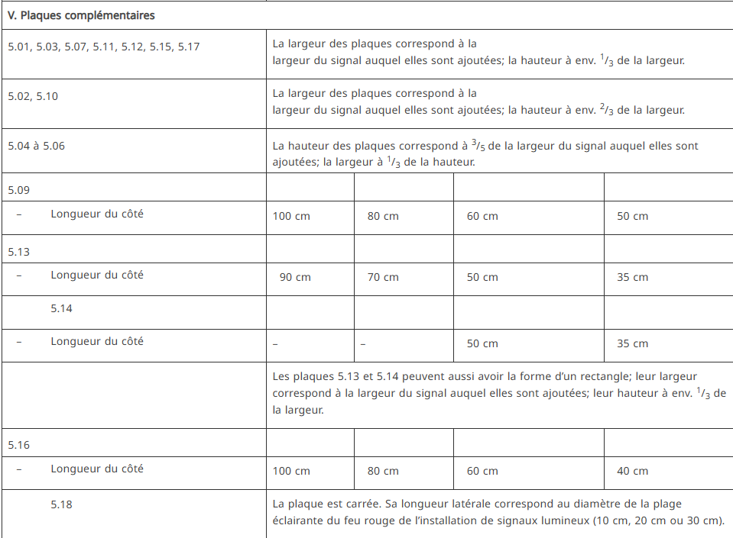
modelling | <tr>  <td colspan=“5">  <p xmlns:mig=“urn:com:c-moria:legi4ch:xslt:migration">V. Plaques complémentaires</p>  </td>  </tr>  <tr>  <td>  <p xmlns:mig=“urn:com:c-moria:legi4ch:xslt:migration">5.01, 5.03, 5.07, 5.11, 5.12, 5.15, 5.17</p>  </td>  <td colspan=“4">  <p>La largeur des plaques correspond à la<br/>largeur du signal auquel elles sont ajoutées; la hauteur à env.<sup xmlns:tmp=“urn:com:c-moria:legi4ch:xslt:temp">1</sup>/<sub>3</sub> de la largeur.</p>  </td>  </tr>  <tr>  <td>  <p xmlns:mig=“urn:com:c-moria:legi4ch:xslt:migration">5.02, 5.10</p>  </td>  <td colspan=“4">  <p>La largeur des plaques correspond à la<br/>largeur du signal auquel elles sont ajoutées; la hauteur à env.<sup xmlns:tmp=“urn:com:c-moria:legi4ch:xslt:temp">2</sup>/<sub>3</sub> de la largeur.</p>  </td>  </tr>  <tr>  <td>  <p xmlns:mig=“urn:com:c-moria:legi4ch:xslt:migration">5.04 à 5.06</p>  </td>  <td colspan=“4">  <p xmlns:mig=“urn:com:c-moria:legi4ch:xslt:migration">La hauteur des plaques correspond à<sup xmlns:tmp=“urn:com:c-moria:legi4ch:xslt:temp">3</sup>/<sub>5 </sub>de la largeur du signal auquel elles sont ajoutées; la largeur à<sup xmlns:tmp=“urn:com:c-moria:legi4ch:xslt:temp">1</sup>/<sub>3</sub>de la hauteur.</p>  </td>  </tr>  <tr>  <td><p xmlns:mig=“urn:com:c-moria:legi4ch:xslt:migration">5.09</p></td>  <td> </td>  <td> </td>  <td> </td>  <td> </td>  </tr>  <tr>  <td><blockList>  <item>  <num>– </num>  <p>Longueur du côté</p>  </item>  </blockList>  </td>  <td><p>100 cm</p></td>  <td><p> 80 cm</p></td>  <td><p> 60 cm</p></td>  <td><p> 50 cm</p></td>  </tr>  <tr>  <td><p xmlns:mig=“urn:com:c-moria:legi4ch:xslt:migration">5.13</p></td>  <td> </td>  <td> </td>  <td> </td>  <td> </td>  </tr>  <tr>  <td>  <blockList>  <item>  <num>– </num>  <p>Longueur du côté</p>  </item>  </blockList>  </td>  <td><p> 90 cm</p></td>  <td><p> 70 cm</p></td>  <td><p> 50 cm</p></td>  <td><p> 35 cm</p></td>  </tr>  <tr>  <td>  <blockList>  <item>  <num>  <placeholder fedlex:message=“E40S10-TAB">[tab]</placeholder>  </num>  <p>5.14</p>  </item>  </blockList>  </td>  <td> </td>  <td> </td>  <td> </td>  <td> </td>  </tr>  <tr>  <td>  <blockList>  <item>  <num>– </num>  <p>Longueur du côté</p>  </item>  </blockList>  </td>  <td><p>–</p></td>  <td><p>–</p></td>  <td><p> 50 cm</p></td>  <td><p> 35 cm</p></td>  </tr>  <tr>  <td> </td>  <td colspan=“4">  <p>Les plaques 5.13 et 5.14 peuvent aussi avoir la forme d’un rectangle; leur largeur correspond à la largeur du signal auquel elles sont ajoutées; leur hauteur à env.<sup xmlns:tmp=“urn:com:c-moria:legi4ch:xslt:temp">1</sup>/<sub>3</sub>de la largeur.</p>  </td>  </tr>  <tr>  <td><p xmlns:mig=“urn:com:c-moria:legi4ch:xslt:migration">5.16</p></td>  <td> </td>  <td> </td>  <td> </td>  <td> </td>  </tr>  <tr>  <td>  <blockList>  <item>  <num>– </num>  <p>Longueur du côté</p>  </item>  </blockList>  </td>  <td><p>100 cm</p></td>  <td><p> 80 cm</p></td>  <td><p> 60 cm</p></td>  <td><p> 40 cm</p></td>  </tr>  <tr>  <td>  <blockList>  <item>  <num>  <placeholder fedlex:message=“E40S10-TAB">[tab]</placeholder>  </num>  <p xmlns:mig=“urn:com:c-moria:legi4ch:xslt:migration">5.18</p>  </item>  </blockList>  </td>  <td colspan="4"><p>La plaque est carrée. Sa longueur latérale correspond au diamètre de la plage éclairante du feu rouge de l’installation de signaux lumineux (10 cm, 20 cm ou 30 cm).</p></td>
Below is an example of a simple table, that contains images:
source | 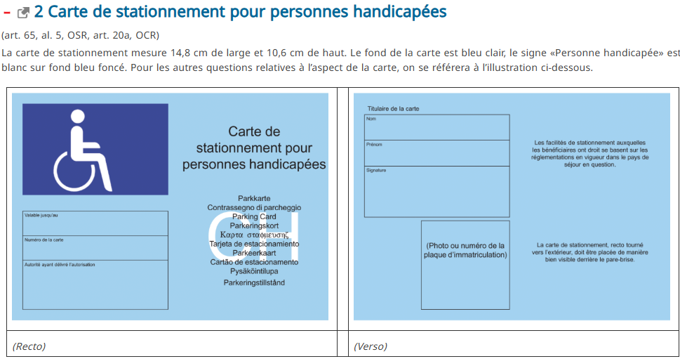
modelling | <level eId=“annex_3/lvl_u1/lvl_2">  <num>2 </num>  <heading>Carte de stationnement pour personnes handicapées</heading>  <content>  <p xmlns:mig=“urn:com:c-moria:legi4ch:xslt:migration">(art. 65, al. 5, OSR, art. 20a<i>, </i>OCR)</p>  <p xmlns:mig=“urn:com:c-moria:legi4ch:xslt:migration">La carte de stationnement mesure 14,8 cm de large et 10,6 cm de haut. Le fond de la carte est bleu clair, le signe «Personne handicapée» est blanc sur fond bleu foncé. Pour les autres questions relatives à l’aspect de la carte, on se référera à l’illustration ci-dessous. </p>  <table fedlex:function="layout">  <tr>  <td xmlns:mig=“urn:com:c-moria:legi4ch:xslt:migration">  <p><img fedlex:original-width=“91" fedlex:original-height="65" fedlex:original-text-width="210" fedlex:original-page-width=“187" src="image/image295.png"/></p>  </td>  <td> </td>  <td xmlns:mig=“urn:com:c-moria:legi4ch:xslt:migration">  <p><img fedlex:original-width=“91" fedlex:original-height="65" fedlex:original-text-width="210" fedlex:original-page-width=“187" src="image/image296.png"/></p>  </td>  </tr>  <tr>  <td>  <p xmlns:mig=“urn:com:c-moria:legi4ch:xslt:migration">(Recto)</p>  </td>  <td> </td>  <td>  <p xmlns:mig=“urn:com:c-moria:legi4ch:xslt:migration">(Verso)</p>  </td>  </tr>  </table>  </content>  </level>
Below is an example of a nested table with images and footnotes:
source | 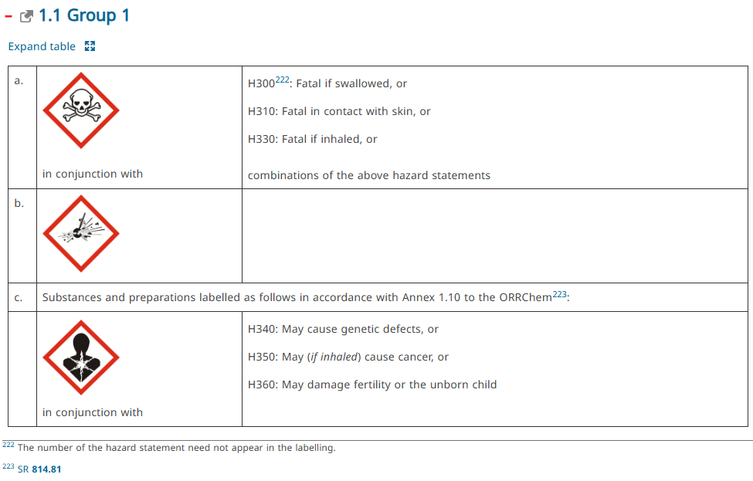
modelling | <level eId="annex_5/lvl_u1/lvl_1/lvl_1_1">  <num>1.1</num>  <heading>Group 1</heading>  <content>  <table border="1">  <tr>  <td><p xmlns:mig=“urn:com:c-moria:legi4ch:xslt:migration">a.</p></td>  <td xmlns:mig=“urn:com:c-moria:legi4ch:xslt:migration">  <p><img fedlex:original-width="12" fedlex:original-height="12" fedlex:original-text-width="148" fedlex:original-page-width="108" src="image/image1.png"/></p>  <p>in conjunction with</p></td>  <td><p xmlns:mig=“urn:com:c-moria:legi4ch:xslt:migration">H300<authorialNote><p> The number of the hazard statement need not appear in the labelling.</p></authorialNote>: Fatal if swallowed, or</p><p xmlns:mig=“urn:com:c-moria:legi4ch:xslt:migration">H310: Fatal in contact with skin, or</p><p xmlns:mig=“urn:com:c-moria:legi4ch:xslt:migration">H330: Fatal if inhaled, or</p><p xmlns:mig=“urn:com:c-moria:legi4ch:xslt:migration">combinations of the above hazard statements</p></td>  </tr>  <tr>  <td><p xmlns:mig=“urn:com:c-moria:legi4ch:xslt:migration">b.</p></td>  <td xmlns:mig=“urn:com:c-moria:legi4ch:xslt:migration"><p><img fedlex:original-width="12" fedlex:original-height="12" fedlex:original-text-width="148" fedlex:original-page-width="108" src="image/image2.png"/></p></td>  <td> </td>  </tr>  <tr>  <td><p xmlns:mig=“urn:com:c-moria:legi4ch:xslt:migration">c.</p></td>  <td colspan="2"><p xmlns:mig=“urn:com:c-moria:legi4ch:xslt:migration">Substances and preparations labelled as follows in accordance with Annex 1.10 to the ORRChem <authorialNote><p><ref fedlex:rs-uri="https://fedlex.data.admin.ch/eli/cc/2005/478" fedlex:rs="814.81" href="https://fedlex.data.admin.ch/vocabulary/legal-taxonomy/9592">SR<b>814.81</b></ref></p></authorialNote>:</p></td>  </tr>  <tr>  <td> </td>  <td xmlns:mig=“urn:com:c-moria:legi4ch:xslt:migration">  <p><img fedlex:original-width="12" fedlex:original-height="12" fedlex:original-text-width="148" fedlex:original-page-width="108" src="image/image3.png"/></p>  <p>in conjunction with</p></td>  <td>  <p xmlns:mig=“urn:com:c-moria:legi4ch:xslt:migration">H340: May cause genetic defects, or</p>  <p xmlns:mig=“urn:com:c-moria:legi4ch:xslt:migration">H350: May (<i>if inhaled</i>) cause cancer, or</p>  <p xmlns:mig=“urn:com:c-moria:legi4ch:xslt:migration">H360: May damage fertility or the unborn child</p></td>  </tr>  </table>  </content>  </level>

Images and pictograms
Akoma Ntoso has different ways to represent images in a file:
At the moment, images are inserted by reference, meaning that they are in an external folder to which points their URI.

Example of a pictogram
source | 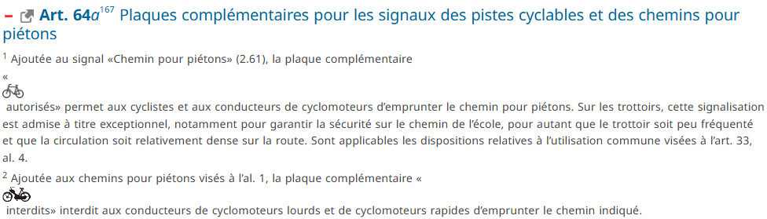
modelling | 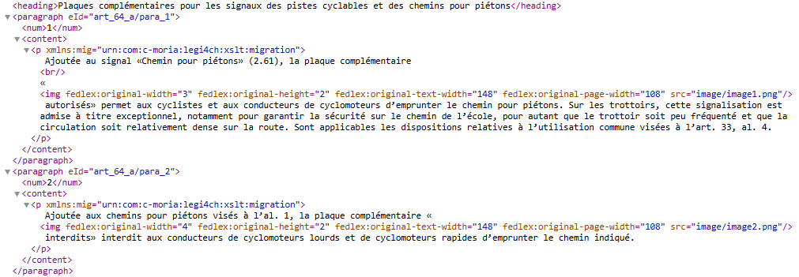

Formulas
Add active links to real samples from Fedlex (Ustra) with formulas and images
mathxml

Example
source
modelling

MODIFICATIONS
Modifying acts describe the impact of a law on other laws. The image below exemplifies how a modification (element mod) is captured within the Fedlex Information Model. The example is taken from the Official Compilation (AS 2022 731).
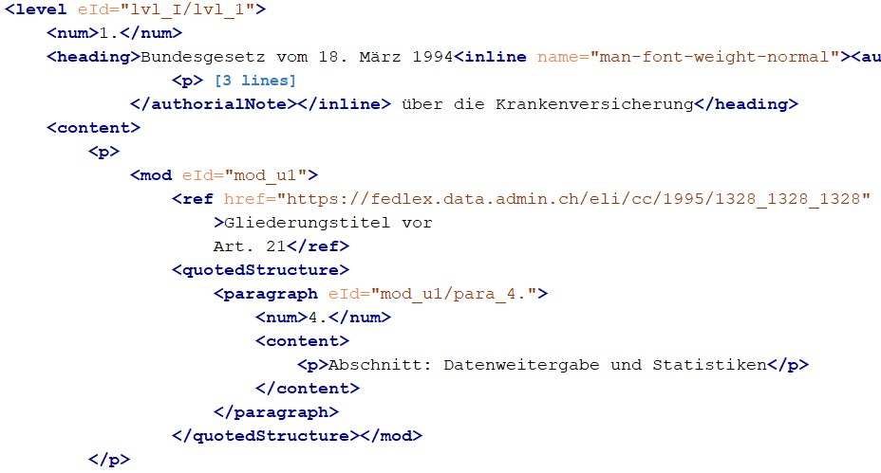
In contrast to the model for an act, that does not have a modifying by nature, a modifying act possesses a unique structure. It permits a content element to be a direct descendant of any hierarchical element (illustrated as level in the above example). Provided that this content element encompasses one or more mod elements, the usual requirement for an article element is circumvented. [FLX-HR-003]
The mod element itself is pivotal as it concretizes the modification, holding a ref attribute that points to the specific act undergoing modification.
Moreover, when the modification contains a replacement text (structured) to be introduced in the impacted law, this text is conveyed within a quotedStructure child element, ensuring that the replacement text is properly structured and encapsulated.
Although a modification is clearly modelled as such in the published XML documents, the impacts and modification history of the impacted acts/documents are not maintained in the XML model described in this guide.
As stated earlier in this reference, the Fedlex platform extends beyond simple data storage, utilizing an advanced knowledge graph to manage a document's comprehensive metadata. This includes impacts, changes and lifecycle stages, chronological records and more. To preserve the integrity and consistency of information, redundancy is avoided by not replicating this metadata within the XML documents themselves.

HANDLING THE ANNEXES
Information that appears after the main body of an act—such as appendices, annexes, forms, and tables—is collectively categorized under components, which serve as annexes to the document. While legislative texts may sometimes present nested annexes within appendices and vice versa, this model adopts a more streamlined approach for simplicity. Components can not be nested.
The image below depicts how an annex is represented within the Fedlex Information Model:
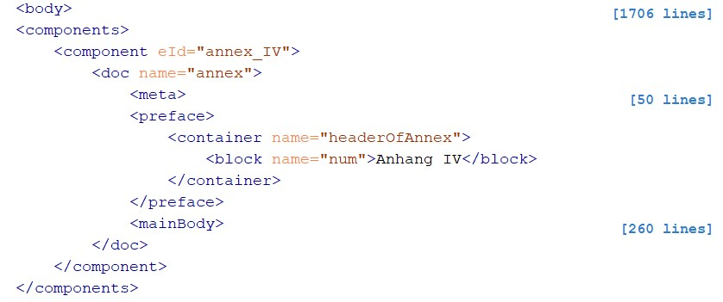
A document according to this model may contain any number of annexes (labeled as component). These components may take one of two forms:
- As an act, utilizing the hierarchical structure previously outlined. This arrangement is typically applied when a modifying act is included as part of an annex.
- As a doc, which applies to all other instances and features a simplified hierarchy. Here, level components are used exclusively, containing block element content.

Missing descriptions to be added to this document:
Add links to Oasis website description of Akoma Ntoso elements
Ajouter les options proposées dans le document pour la conversion du processus de consultation

List of Annexes
Annex I - Schematron rules description and codes
Annex II – List of acronyms used in this document

Annex I
Schematron rules description and codes
ID | Category | Description | Rule
FLX-RT-001 | Document Root Restrictions | the document root should be "act" | The document root should only contain an act
FLX-PF-001 | Preface Restrictions | the preface should have a docNumber | Missing docNumber in preface
FLX-PF-002 | Preface Restrictions | the preface should have a docTitle | Missing docTitle in preface
FLX-BD-001 | Body Restrictions | lists all elements allowed as a top level in an act | Illegal element <value-of select="local-name()"/> in body
FLX-HR-001-ti | Hierarchical Component Restrictions | title has strict rules on what content it can have | Hierarchy mismatch on <value-of select="local-name()"/>
FLX-HR-002-ti | Hierarchical Component Restrictions | title requires an eId | <value-of select="local-name()"/> needs a unique identifier eId
FLX-HR-001-bk | Hierarchical Component Restrictions | book has strict rules on what content it can have | Hierarchy mismatch on <value-of select="local-name()"/>
FLX-HR-002-bk | Hierarchical Component Restrictions | book requires an eId | <value-of select="local-name()"/> needs a unique identifier eId
FLX-HR-001-pt | Hierarchical Component Restrictions | part has strict rules on what content it can have | Hierarchy mismatch on <value-of select="local-name()"/>
FLX-HR-002-pt | Hierarchical Component Restrictions | part requires an eId | <value-of select="local-name()"/> needs a unique identifier eId
FLX-HR-001-ch | Hierarchical Component Restrictions | chapter has strict rules on what content it can have | Hierarchy mismatch on <value-of select="local-name()"/>
FLX-HR-002-ch | Hierarchical Component Restrictions | chapter requires an eId | <value-of select="local-name()"/> needs a unique identifier eId
FLX-HR-001-sh | Hierarchical Component Restrictions | subchapter has strict rules on what content it can have | Hierarchy mismatch on <value-of select="local-name()"/>
FLX-HR-002-sh | Hierarchical Component Restrictions | subchapter requires an eId | <value-of select="local-name()"/> needs a unique identifier eId
FLX-HR-001-sc | Hierarchical Component Restrictions | section has strict rules on what content it can have | Hierarchy mismatch on <value-of select="local-name()"/>
FLX-HR-002-sc | Hierarchical Component Restrictions | section requires an eId | <value-of select="local-name()"/> needs a unique identifier eId
FLX-HR-001-ss | Hierarchical Component Restrictions | subsection has strict rules on what content it can have | Hierarchy mismatch on <value-of select="local-name()"/>
FLX-HR-002-ss | Hierarchical Component Restrictions | subsection requires an eId | <value-of select="local-name()"/> needs a unique identifier eId
FLX-HR-001-lv | Hierarchical Component Restrictions | level requires an eId | Hierarchy mismatch on <value-of select="local-name()"/>
FLX-HR-002-lv | Hierarchical Component Restrictions | a level is 'transparent' so the local name is the first non-transparent node on the ancestor axis | <value-of select="local-name()"/> needs a unique identifier eId
FLX-HR-003 | Hierarchical Component Restrictions | level in body can only have content if the content caters for modifications | content in <value-of select="local-name()"/> only allowed for modifications
FLX-HR-004 | Hierarchical Component Restrictions | level requires an eId | <value-of select="local-name()"/> needs a unique identifier eId
FLX-HD-001 | Heading Section Restriction | restrictions on num (num?, heading?, subheading?) | A hierarchical component should have a maximum of one <value-of select="local-name()"/>
FLX-HD-002 | Heading Section Restriction | restrictions on num (num?, heading?, subheading?) | If a hierarchical component has both a <value-of select="local-name()"/> and a heading, the num should come first
FLX-HD-003 | Heading Section Restriction | restrictions on num (num?, heading?, subheading?) | If a hierarchical component has both a <value-of select="local-name()"/> and a subheading, the num should come first
FLX-HD-004 | Heading Section Restriction | restrictions on heading (num?, heading?, subheading?) | A hierarchical component should have a maximum of one <value-of select="local-name()"/>
FLX-HD-005 | Heading Section Restriction | restrictions on heading (num?, heading?, subheading?) | If a hierarchical component has both a <value-of select="local-name()"/> and a subheading, the heading should come first
FLX-HD-006 | Heading Section Restriction | restrictions on heading (num?, heading?, subheading?) | A hierarchical component should have a maximum of one <value-of select="local-name()"/>
FLX-ART-001 | Article Restriction | in an article num is mandatory | num is mandatory in a <value-of select="local-name()"/>
FLX-ART-002 | Article Restriction | in an article only heading elements, paragraphs or subdivisions are allowed | Content not allowed in <value-of select="local-name()"/>
FLX-ART-003 | Article Restriction | article requires an eId | <value-of select="local-name()"/> needs a unique identifier eId
FLX-SD-001 | Article Restriction | in a subdivision only heading elements and paragraphs are allowed | Content not allowed in <value-of select="local-name()"/>
FLX-SD-002 | Article Restriction | a subdivision is only allowed in the context of an article | <value-of select="local-name()"/> only allowed in the context of an article
FLX-SD-003 | Article Restriction | subdivision requires an eId | value-of select="local-name()"/> needs a unique identifier eId
FLX-PR-001 | Article Restriction | in a paragraph only heading elements and content are allowed | Content not allowed in <value-of select="local-name()"/>
FLX-PR-002 | Article Restriction | a paragraph is only allowed in the context of an article or a subdivision | <value-of select="local-name()"/> only allowed in the context of an article or subdivision
FLX-PR-003 | Article Restriction | paragraph requires an eId | <value-of select="local-name()"/> needs a unique identifier eId
FLX-TXT-001 | Text Content Restriction | Text Content Restriction | <value-of select="local-name()"/> restricted to heading type elements only
FLX-XF-001 | Extension Attributes Restrictions | only defined fedlex extension attributes are allowed throughout the document | [{$id}] Fedlex extension attribute not supported: <value-of select="local-name()"/>
FLX-XF-002 | Extension Attributes Restrictions | fedlex:generator only allowed on FRBR format | Fedlex extension attribute 'generator' not allowed on <value-of select="parent::*/local-name()"/>
FLX-XF-003 | Extension Attributes Restrictions | fedlex:role values are either 'reference' or 'marginal' | Fedlex extension attribute 'role', value not allowed: <value-of select="."/>
FLX-XF-004 | Extension Attributes Restrictions | fedlex:role value 'marginal' only allowed on level elements | Fedlex extension attribute 'role', with value 'marginal' not allowed on <value-of select="parent::*/local-name()"/>
FLX-XF-005 | Extension Attributes Restrictions | fedlex:role value 'reference' only allowed on subheading elements | Fedlex extension attribute 'role', with value 'marginal' not allowed on <value-of select="parent::*/local-name()"/>

Annex II
List of international acronyms and definitions used in this document
Acronym | Definition | Source
AKN | Akoma Ntoso (xml schema) | http://akomantoso.info/
AKN4CH | Akoma Ntoso subschema for Switzerland | N/A
XML | eXtended Markup Language | https://www.w3schools.com/xml/xml_whatis.asp
LegalDocML | Legal Document xml Oasis standard | https://www.oasis-open.org/committees/tc_home.php?wg_abbrev=legaldocml#overview
OGI | Open governance Initiative | https://en.wikipedia.org/wiki/Open_Government_Initiative
OASIS | Open standard | https://www.oasis-open.org/
Jolux | Journal du Luxembourg | https://swiss.github.io/fedlex-jolux/
IFLA | International Federation of Library Associations | https://www.ifla.org/
FRBR | Functional Requirements for Bibliographic Records | https://en.wikipedia.org/wiki/Functional_Requirements_for_Bibliographic_Records
ELI | European Legislation Identifier | https://en.wikipedia.org/wiki/European_Legislation_Identifier
URI | Uniform Resource Identifiers | https://en.wikipedia.org/wiki/Uniform_Resource_Identifier
IRI | Internationalized Resource Identifier | https://en.wikipedia.org/wiki/IRI
HTML | Hyper Text Markup Language | https://www.w3schools.com/html/default.asp
SPARQL | Semantic query language for databases | https://en.wikipedia.org/wiki/SPARQL
Schematron | Rule-based validation language | https://en.wikipedia.org/wiki/Schematron
EOP | End of Page | https://docs.oasis-open.org/legaldocml/akn-core/v1.0/os/part2-specs/os-part2-specs_xsd_Element_eop.html
EOL | End of Line | https://docs.oasis-open.org/legaldocml/akn-core/v1.0/os/part2-specs/os-part2-specs_xsd_Element_eol.html
FENC | Functionally Equivalent Naming Conventions | https://docs.oasis-open.org/legaldocml/akn-nc/v1.0/csprd03/akn-nc-v1.0-csprd03.html

List of Fedlex acronyms and definitions
Acronym | Definition | Source
Fedlex | Federal Collection of Swiss Laws | https://www.fedlex.admin.ch/
OPC | Offcial Publication Center of the Swiss Federal Chancellery | Official Publications Centre (OPC)
KAV | Kompetenzzentrum Amtliche Veröffentlichungen (KAV) (DE) | Kompetenzzentrum Amtliche Veröffentlichungen (KAV)
CPU | Center da las publicaziuns uffizialas (RM) | Center da las publicaziuns uffizialas (CPU)
CPU | Centro delle pubblicazioni ufficiali (IT) | Centro delle pubblicazioni ufficiali (CPU)
CPO | Centre des publications officielles (FR) | Centre des publications officielles (CPO)
FG | Federal Gazette | Bundesblatt | Fedlex
BBl | Bundesblatt (DE) | https://www.fedlex.admin.ch/de/fga/index
FF | Feuille fédérale (FR) | Feuille fédérale | Fedlex
FF | Foglio federale (IT) | Foglio federale | Fedlex
AS | Amtliche Sammlung (DE) | Amtliche Sammlung | Fedlex
RO | Recueil officiel (FR) | Recueil officiel | Fedlex
RU | Raccolta ufficiale (IT) | Raccolta ufficiale | Fedlex
SR | Systematische Rechtssammlung (DE) | Systematische Rechtssammlung | Fedlex
RS | Recueil systématique (FR) | Recueil systématique | Fedlex
RS | Raccolta sistematica (IT) | Raccolta sistematica | Fedlex
CS | Collecziun sistematica dal dretg federal (RM) | Collecziun sistematica dal dretg federal | Fedlex
CC | Classified Compilation | Classified Compilation | Fedlex
OC | Official Compilation | N/A
LCEG | Legge federale concernente le piattaforme per la comunicazione elettronica in ambito giudiziario (IT) | RS 172.023 - Legge federale del 20 dicembre 2024 concernente le piattaforme per la comunicazione elettronica in ambito giudiziario (LCEG) | Fedlex
BEKJ | Bundesgesetz über die Plattformen für die elektronische Kommunikation in der Justiz (DE) | SR 172.023 - Bundesgesetz vom 20. Dezember 2024 über die Plattformen für die elektronische Kommunikation in der Justiz (BEKJ) | Fedlex
LPCJ | Loi fédérale sur les plateformes de communication électronique dans le domaine judiciaire (FR) | RS 172.023 - Loi fédérale du 20 décembre 2024 sur les plateformes de communication électronique dans le domaine judiciaire (LPCJ) | Fedlex
SVG | Strassenverkergesetz (DE) | SR 741.01 - Strassenverkehrsgesetz vom 19. Dezember 1958 (SVG) | Fedlex
LCR | Loi fédérale sur la circulation routière (FR) | RS 741.01 - Loi fédérale du 19 décembre 1958 sur la circulation routière (LCR) | Fedlex
LVT | Lescha davart il traffic (RM) | SR 741.01 - Lescha davart il traffic sin via dals 19 da december 1958 (LTV) | Fedlex
LCStr | Legge federale sulla circolazione stradale (IT) | RS 741.01 - Legge federale del 19 dicembre 1958 sulla circolazione stradale (LCStr) | Fedlex
OSStr | Ordinanza sulla segnaletica stradale (IT) | RS 741.21 - Ordinanza del 5 settembre 1979 sulla segnaletica stradale (OSStr) | Fedlex
SSV | Signalisationsverordnung | SR 741.21 - Signalisationsverordnung vom 5. September 1979 (SSV) | Fedlex
OSR | Ordonnance sur la signalisation routière | RS 741.21 - Ordonnance du 5 septembre 1979 sur la signalisation routière (OSR) | Fedlex

OASIS LegalDocumentML (LegalDocML) TC | OASIS
https://www.fedlex.admin.ch/en/home
https://www.oasis-open.org/committees/tc_home.php?wg_abbrev=legaldocml#technical
https://docs.oasis-open.org/legaldocml/akn-core/v1.0/os/part2-specs/schemas/
https://docs.oasis-open.org/legaldocml/akn-core/v1.0/akn-core-v1.0-part2-specs.html
http://www.akomantoso.org/?page_id=12
https://www.schematron.com/
http://dublincore.org/
http://www.ifla.org/VII/s13/frbr/frbr.pdf
RU 2025 583 - Legge federale del 20 dicembre 2024 concernente le piattaforme per la comunicazione elettronica in ambito giudiziario (LCEG) | Fedlex
SR 101 - Bundesverfassung der Schweizerischen Eidgenossenschaft vom 18. April 1999 | Fedlex
RU 2025 583 - Legge federale del 20 dicembre 2024 concernente le piattaforme per la comunicazione elettronica in ambito giudiziario (LCEG) | Fedlex
SR 101 - Bundesverfassung der Schweizerischen Eidgenossenschaft vom 18. April 1999 | Fedlex
RU 2025 583 - Legge federale del 20 dicembre 2024 concernente le piattaforme per la comunicazione elettronica in ambito giudiziario (LCEG) | Fedlex
SR 101 - Bundesverfassung der Schweizerischen Eidgenossenschaft vom 18. April 1999 | Fedlex
RU 2025 583 - Legge federale del 20 dicembre 2024 concernente le piattaforme per la comunicazione elettronica in ambito giudiziario (LCEG) | Fedlex
RU 2025 583 - Legge federale del 20 dicembre 2024 concernente le piattaforme per la comunicazione elettronica in ambito giudiziario (LCEG) | Fedlex
RU 2025 583 - Legge federale del 20 dicembre 2024 concernente le piattaforme per la comunicazione elettronica in ambito giudiziario (LCEG) | Fedlex
https://www.fedlex.admin.ch/eli/cc/1999/404/de
https://fedlex.data.admin.ch/en-CH/sparql
xmlns:fedlex="http://fedlex.admin.ch/"
See schematron rule description in Annex I
See schematron rule description in Annex I
https://www.fedlex.admin.ch/eli/cc/2021/860/it
European Legislation Identifier - Wikipedia
A full list of acronyms used in this document is available in Annex II
SR 101 - Bundesverfassung der Schweizerischen Eidgenossenschaft vom 18. April 1999 | Fedlex
See schematron rule description in Annex I. ‘xx’ in the rule identifier indicates all rules following this pattern.
See schematron rule description in Annex I.
See schematron rule description in Annex I.
See schematron rule description in Annex I.
See schematron rule description in Annex I.
RS 741.01 - Loi fédérale du 19 décembre 1958 sur la circulation routière (LCR) | Fedlex
RS 741.01 - Loi fédérale du 19 décembre 1958 sur la circulation routière (LCR) | Fedlex
SR 813.11 - Ordinance of 5 June 2015 on Protection against Dangerous Substances and Preparations (Chemicals Ordinance, ChemO) | Fedlex
See schematron rule description in Annex I.
RS 101 - Constitution fédérale de la Confédération suisse du 18 avril 1999 | Fedlex
https://www.fedlex.admin.ch/eli/cc/24/233_245_233/de
See schematron rule description in Annex I.
RS 741.21 - Ordonnance du 5 septembre 1979 sur la signalisation routière (OSR) | Fedlex
RS 741.21 - Ordonnance du 5 septembre 1979 sur la signalisation routière (OSR) | Fedlex
RS 741.21 - Ordonnance du 5 septembre 1979 sur la signalisation routière (OSR) | Fedlex
SR 813.11 - Ordinance of 5 June 2015 on Protection against Dangerous Substances and Preparations (Chemicals Ordinance, ChemO) | Fedlex
RS 741.21 - Ordonnance du 5 septembre 1979 sur la signalisation routière (OSR) | Fedlex
RS 741.21 - Ordonnance du 5 septembre 1979 sur la signalisation routière (OSR) | Fedlex
https://www.fedlex.admin.ch/eli/oc/2022/731/de
See schematron rule description in Annex I.

